ABSTRACT
This study examines the key factors influencing customer churn in Nigeria’s telecommunications sector, focusing on MTN and Airtel. Using survey data from 1,383 respondents, the research applied supervised machine learning models—including Decision Tree, Random Forest, Support Vector Machine (SVM), and Extreme Gradient Boosting—to predict churn and identify critical factors affecting customer behavior. Among these models, SVM demonstrated the best performance with an accuracy of 65%, a precision of 43%, recall of 65%, and an F1-score of 52%. Findings indicate that service quality, network coverage, billing issues, and customer service significantly impact churn. Specifically, 65% of respondents cited poor network coverage, while 54% mentioned billing discrepancies as key reasons for switching providers. Additionally, younger customers (aged 18-30), prepaid subscribers, and those lodging frequent complaints (averaging three per month) were more likely to leave. The study highlights the need for telecommunication providers to improve service quality, address customer grievances promptly, and implement targeted retention strategies for at-risk customers. These findings underscore the broader relevance of machine learning in predicting customer behavior and shaping strategic business decisions. The research contributes valuable insights into Nigeria’s telecommunication industry, emphasizing the importance of predictive analytics in customer retention. The results serve as a guide for telecommunication providers, policymakers, and business strategists to enhance service delivery, mitigate churn, and maintain competitiveness in the market.

CHAPTER ONE

INTRODUCTION

1.1 Background of Study
In today’s era where connectivity is one of the basic human necessities, and telecommunications industry plays an important role in the development of societies’ digital base. These include the busy cities with vibrant economic activities and the rural areas that want to be connected, by providing communication and transaction services as well as information. While the industry advances, the problem of customer loyalty in the context of rising competition becomes even more significant. This paper aims at exploring the best approach to predict customer churn using complex machine learning models, which is a crucial task to ensure growth and profitability of the telecommunication industry.
Telecommunication remains one of the major industries that shape growth and development within the global economy. The telecommunications industry in America has well-developed facilities, high technologies, and high competition among the leading companies such as AT&T, Verizon, and T-Mobile. These companies are always working hard to deliver fast internet, integrated mobility, and other advanced solutions such as 5G to keep the United States on the map of telecommunications progress (Gartner, 2021). For instance, AT&T negotiation in fiber optics and the edges technology has been pivotal in increasing the network speed and availability which in one way is resultant for customer retention.
Nigeria telecommunication sector is one of the largest and fastest growing in Africa that has recorded phenomenal growth over the last two decades. Measures that liberalized the sector prior to the year 2000s paved way for private participation and resulted in the scale mobile subscription and usage of the internet. The industry is made up of players including MTN Nigeria, Airtel Nigeria, Globacom, 9mobile through which consumers can access voice and Short Message Service (SMS) and data as well as mobile money Newman et al. 2015).
The generation and use of mobile technology has moved with a fast pace in Nigeria, where mobile subscriptions passed 200 million in the year 2023 (Nigerian Communications Commission, 2023). This growth has been as a result of affordability of smartphones, cut-throat prices and fancy service delivery, and this makes telecommunication an essential part of improvement of socioeconomic life of Nigeria. MoMo by MTN Nigeria has immensely enhanced financial mobilization and has been offering banking solutions to many unserved Nigerians.
However, the industry suffers a number of threats such as inadequate infrastructural development, restrictive policies as well as high rivalry. However, the Nigerian telecommunications has continued to be a competitive and key sub-sector of the economy in terms of enrolment to GDP and employment. Some of these challenges are being addressed through development of the National Broadband Plan in Nigeria in order to increase accessibility of broadband while enhancing the quality of infrastructure.
The telecommunications sector in Nigeria, one of the most developed segments of the African telecommunication market, has been developing rapidly during the last two decades. In the early 2000 the sector has been liberalized to allow private investment hence mobile subscriptions and internet growth. The market is fairly well controlled by prominent players like: MTN Nigeria Communications Limited (MTN Nigeria), Airtel Nigeria Limited, Glo Mobile, and 9Mobile Limited as they provide the mobile subscription services for voice, Short Message Service (SMS), mobile data and mobile money services (Newman et al.,2015).
Mobile technology is therefore rapidly growing since Nigeria is among the first-tier telecommunications markets worldwide, with the active subscription of mobile telecommunications standing at over 200 million in 2023. This growth has therefore been facilitated by the availability of cheap smartphones, competent and attractive prices for telecommunications services, as well as several other attractive and unique services, making telecommunications an essential of the Nigeria’s economic evolution. Through MoMo, which is MTN Nigeria’s mobile money service offering banking services to millions of Nigeria’s unbanked people, has gone up tremendously for financial inclusion.
Nonetheless, challenges persist such as infrastructure development challenges, regulations and competitors’ pressures. However, the sector has faced these challenges, the sector is still growing in Nigeria and provides a significantly large boost to the nation’s Gross Domestic Product (GDP) and employment. Some of these challenges are sought to be solved through development of new infrastructure like the Nigerian National Broadband Plan seeking to increase the broadband penetration and enhance the quality of networks. Similarly, various methods employed include:
- Personalized Services: Telecommunications providers such as Verizon and China Mobile leverage data analytics and machine learning to offer personalized services and recommendations based on customer preferences and behavior. Verizon's use of predictive analytics to identify at-risk customers and offer targeted retention campaigns has significantly reduced churn rates.
- Loyalty Programs: Companies like Airtel India and MTN Nigeria implement loyalty programs that reward customers for their continued patronage, encouraging long-term engagement and reducing churn. MTN's "Y'ello Rewards" program offers discounts, free data, and exclusive offers to loyal customers, enhancing customer retention.
- Competitive Pricing and Bundling: Offering competitive pricing and bundling services, such as combining mobile, internet, and TV services, helps companies like Reliance Jio and Vodafone Idea attract and retain customers. Reliance Jio's bundling of digital services, including JioTV and JioCinema, with its mobile plans has increased customer stickiness.
- Proactive Customer Support: Proactive customer support, including regular check-ins and prompt resolution of issues, is a key strategy employed by companies like T-Mobile and China Telecom to maintain customer satisfaction and loyalty. T-Mobile's implementation of a customer feedback loop to continuously improve service quality has been effective in retaining customers.
Customer churn, the phenomenon where customers discontinue their services with a company, poses a significant challenge for telecommunications companies. High churn rates can lead to substantial revenue losses, increased marketing and acquisition costs, and a negative impact on brand reputation.
The impact of customer churn is multifaceted and can be described as follows:
- Revenue Loss: When customers leave, companies lose not only the immediate revenue from their services but also potential future earnings from up-selling and cross-selling opportunities. For example, losing a high-value customer who subscribes to premium services can significantly impact the company's revenue.
- Increased Costs: Acquiring new customers is often more expensive than retaining existing ones. High churn rates necessitate increased spending on marketing and promotional activities to attract new customers. The cost of acquiring a new customer can be five to ten times higher than retaining an existing one (Huang and Wang, 2018).
- Brand Image: Frequent customer churn can damage a company's brand image and reputation. Customers who leave due to dissatisfaction may share their negative experiences, influencing potential customers' perceptions. Negative reviews on social media and review sites can amplify the impact, deterring prospective customers.
- Operational Efficiency: High churn rates can disrupt operational efficiency, as companies must continuously adapt their strategies and processes to address the reasons behind churn. This constant need for adaptation can strain resources and divert attention from other strategic initiatives.
Core problems of many telecommunications companies include unhappy customers whose contracts have been terminated. For example, in Nigeria 9mobile has seen customers defecting in several ways triggered by issues such as poor network quality, customer care concerns and competition forces that come with serious players like MTN Nigeria and Airtel Nigeria. The need to reduce expenditure has also led the company to hive off most of its capital expenses, thereby denying it funds for network enhancement, which has worsened the churn issue.
Customer churn in the telecommunications industry can be attributed to several factors:
- Network Quality: User Experience- one of the major factors for churn is the erratic nature of call and data connections, drop calls, slow internet speed and areas of restricted network coverage. This distortion gives customers expectation of reliable and high quality network service; any failure in meeting this expectation will lead to dissatisfaction and churn.
- Customer Service: Lack of or poor response to customer service causes customer irritation hence they shift to other companies. Complaint and dissatisfaction such as long hours waiting, unsolved problems and no attendant care are some of the reasons that lead to churn.
- Pricing: High tariffs and hidden charges act as a put off due to the fact that customers have the option of moving to the next available cheaper deal. Common understanding is that customer should never be overcharged and where possible their ought to be added value services offered at a cheap price.
- Competition: Sometimes the competition is high and the offers from other service providers look even more attractive, customers tend to change providers. The competitors have also been known to start marketing and promotional campaigns that could easily sway the customer if the current service provider is not prepared to match the price and value for money offered, as well.
- Lack of Personalization: It is known that customers expect that certain individual services are provided for being tailored for their needs. Similar to the case of churn, marketers often relate it to failure to provide or to meet user expectations. Customers want to receive information that concerns them specifically; they want to receive offers and content that relates to what they are interested in.
The telecommunications industry, a vital sector in the global economy, faces the dual challenges of fierce competition and customer churn. While the industry's growth and technological advancements have transformed communication and connectivity, retaining customers remains a critical concern. Understanding the factors influencing customer churn and employing effective retention strategies are essential for telecommunications companies to sustain their growth and profitability.

1.2 Problem Definition
Predicting customer churn is a complex task due to several factors. Firstly, telecommunications companies handle vast amounts of data, including call detail records, usage patterns, and customer demographics, which need to be effectively analyzed to identify churn predictors. Secondly, customer behavior is influenced by numerous variables, such as service quality, pricing, customer service experiences, and competitor actions, making it challenging to pinpoint the exact reasons for churn. Moreover, the dynamic nature of the market, with frequent changes in technology and service offerings, adds to the difficulty of developing robust predictive models.
Addressing customer churn is critical for telecommunications companies to maintain revenue, reduce acquisition costs, and sustain competitive advantage. High churn rates can lead to significant financial losses and undermine customer loyalty. Therefore, implementing effective churn prediction and retention strategies is essential for long-term success.
This study aims to solve these challenges by employing advanced machine learning models to predict customer churn in the telecommunications sector. By leveraging large datasets and sophisticated algorithms, the study will identify key churn indicators and develop predictive models that can accurately forecast churn events. These insights will enable telecommunications companies to implement targeted retention strategies, such as personalized offers and proactive customer support, to mitigate churn and enhance customer loyalty.

1.3 Aim and Objectives of Study
The aim of this study is to predict customer churn using machine learning models. The specific objectives are:
- To obtain data in order identify key factors influencing customer churn in Nigerian telecommunications industry
- To design a database to store relevant customer and telecom data for preprocessing, feature engineering and exploratory analysis
- To develop a machine-based framework for churn prediction in Nigerian telecommunications industry
- To evaluate and compare the performance of the models using appropriate metrics

1.4 Research Questions
- What are the key factors that influence customer churn in telecommunications?
- Which machine learning models are most effective in predicting customer churn?
- How do different machine learning models compare in terms of accuracy and performance?

1.5 Research Justification
To achieve the research objectives, this study will utilize secondary data obtained from MTN and Airtel subscriber databases. The dataset will include customer demographics, service usage patterns, billing information, complaint records, and churn status. Key software tools such as Python and its libraries (Pandas, NumPy, Scikit-learn, and Matplotlib) will be employed for data cleaning, analysis, and visualization.
The methods involve descriptive and predictive analytics. Descriptive analysis will identify trends and patterns, while machine learning models—Decision Tree, Random Forest, Support Vector Machine and XGBoost—will be developed to predict churn. These models will be evaluated based on accuracy, precision, recall, and F1-score to determine their effectiveness in identifying factors influencing churn.

1.6 Significance of Study
The results of this study constitute a number of valuable implications for telecommunications practical application, representing the following benefits. It allows telecommunications firms to identify which customers are likely to churn so they can undertake special retention efforts such as customer offers or incentives and better customer service interventions. It is these measures that can slash churn rates to the ground, thus providing the company with stability of customer flow and, consequently, of revenues. Theoretical models derived from this research will help to forecast customers that are likely to present a risk, and thus facilitate rational resource deployment. Targeting and applying retention strategies to high churning customers save the firm a lot of money used in the extensive marketing and customer acquisition. Furthermore, since the factors underlying customer churn rate are ascertained some of the most frequent complaints and issues can be resolved to improve the general quality of offered services. Changes in network reliability and cost-effectiveness, availability and clarity of tariffs, and customer care services will result to increased customer satisfaction and the sizes of the loyal customers base. Using high level of machine learning in churn prediction can be a good selling point, so firms can easily adjust to the market changes and consumer demands hence drawing more customers thus expanding the market share. Last but not the least, the findings of the churn prediction models will be useful in making optimal decisions from the strategic management perspectives at multiple organizational tiers to fight churn and manage customer value properly.
From an academic perspective, this research adds onto existing literature and knowledge to the field of customer churn prediction focused on the application of machine learning algorithms. This enhances the understanding of very large telecommunications data, especially the relative performance of different predictive models. Thus, this research effort provides a practical emphasis on the application of advanced algorithms while filling the gap between theoretical and applied investigation. Further, the findings give insights to the many factors affecting customer churn, diversifying the available customer behavior and Customer retention literature.
The study's methodology and findings can serve as a reference for future research, encouraging further exploration and innovation in the field of data-driven customer relationship management. Ultimately, this research advances the understanding of how machine learning can be leveraged to address critical business challenges, fostering a deeper integration of technology and business strategy in academia.

1.7 Scope of Study
This study aims to predict customer churn in Nigeria's telecommunications sector using machine learning models such as Support Vector Machine, Decision Trees, Random Forest, and Extreme Gradient Boosting (XGBoost). These models are evaluated using metrics including accuracy, precision, recall, and F1-score to ensure reliable predictions. The analysis focuses on data from MTN Nigeria and Airtel Nigeria, collected over three years to capture customer behavior and market trends. The geographical scope encompasses both urban and rural areas nationwide.

1.8 Limitations of Study
However, the study has limitations. It relies on secondary data from telecom operators, which may be subject to accuracy and completeness issues. External factors such as inflation or competitor strategies are not considered, potentially influencing churn. Additionally, findings are specific to MTN and Airtel, limiting generalization to other operators. These constraints highlight the need for future research incorporating broader datasets and additional socioeconomic variables to enhance predictive accuracy and scope.

1.9 Operational Definition of Terms
- Customer Churn: In the framework of this research, Customer churn means that the customers who subscribed to the telecom services end their relationship with the provider forever, either by canceling their contracts or not renewing their prepaid plans.
- Machine Learning Models: Artificial intelligence is a method of data analysis which allows a computing system to automatically learn the pattern in the given data and then use the data to make a decision. In this research, data mining tools such as machine learning models are used to analyze customer data to develop a churn prediction model by analyzing historical Telecom data.
- Predictive Analytics: Customer churn is an example of an application of predictive analytical techniques where quantitative historical data analysis and score carding relying on statistical modeling, machine learning theory and artificial intelligence techniques in order to predict future customer behavior patterns.
- Telecommunication Industry: This is the industry that deals with the communication of information through technology equipment, for example, telephone, internet, Wireless Local Area Network. It includes the lipid that sell voice, data, and multimedia to the consumers and other businesses.
- Network Coverage: This denotes the region that user can access a telecommunication network. It defines how you are connected to make voice calls, send messages or browse the web, among others.
- Service Quality: This regards the general ability of the telecommunication services to provide quality services by aspects such as the quality of calls, internet speeds and frequency of call disruptions or call drops. Quality services assist in creating and maintaining good relationship with the buyers.
- Personalized Services: It is a special kind of product or service that is developed with special consideration to suit a particular customer. Some examples include accession services like data plans that might be unique to some customers, rewards for being loyal customers or advertisements created based on the usage record of a certain customer.
- Customer Demographics: It denotes the probabilistic tendencies of users of telecommunication solutions, including but not limited to age, gender, income and education levels, or geographical location. Customer demographic information is of utmost importance in developing and implementing service and marketing strategies.
- Performance Evaluation: This involves assessing the effectiveness and efficiency of telecommunication services or strategies. It includes measuring metrics such as customer satisfaction, network reliability, revenue growth, and the accuracy of predictive models in identifying customer churn.

CHAPTER TWO

LITERATURE REVIEW

2.1 Concept of Customer Churn in Telecommunications
Customer churn, sometimes called customer attrition, is one of the key measures of telecommunications companies that reflects the rate of customer desertion (Chang et al.,2024). It is crucial to define churn and its types to be able to create proper retention strategies. Broadly, customer churn can be classified into two categories: customer churn and forced churn (Amin et al.,2018).
This kind of churn is one in which customers themselves choose to end their relationship with a provider. This decision can be as a result of many reasons with the main one being customer dissatisfaction or the perceived better offers from other service providers. A major motivator is dissatisfaction with services received where customer expectations and their goal have not been met from the service provider end through frequent call drops, slow internet connection or low network coverage. For instance, Huang and Wang (2018) deem that among the key account as determinants of customer loyalty are network performance in the telecommunications sector. In addition, the matters that concern customer relations are also very significant. This avails operational service durations relative to the amounts of time that customers have to wait for assistance, unresolved issues, and strands of communication that objective customers, compelling them to shift their allegiance to better-supporting providers (Lee, 2020).
Pricing and billing issues as a category are generally considered to be a significant reason for voluntary churn. Subscribers might also be unfollowing due to existence of high costs or hidden charges as well as wrong billings (Smith, 2019). In a competitive environment where price factors can dictate the customers’ decision, simplicity in billing and reasonable price should be employed. Also, the competitors’ attractive offers are a major reason that customers switch sides. Telecom companies often undertake cutthroat promotional strategies to capture the attention of the consumer with respect to the pricing plans, service packages and value-added services (Kim et al., 2021).
Voluntary churn can also be brought about by changes in life style. The factors that can cause customers to cancel their services include; Relocation, job loss, need for a different job, financial strains, and family issues. For instance, a customer migrating to an area with inadequate service provision from the current provider may go to the rival firm (Bandyopadhyay and Martell, 2017). Moreover, technological dynamics also appear to be at work, in that customers may migrate to different providers if the latter offers newer technologies, for instance 5G networks than what their current provider can provide., Wirtz et al (2023).
On the other hand, the involuntary churn takes place when the service provider ends the customer relationship. It is different from user-initiated churn, in that it may stem from factors such as non payment, regulatory changes, internal business decisions by the service provider. Involuntary churn can further be described as erroneous churn caused by non-payment where customers who haven’t paid their bills are disconnected (Anderson & Srinivasan, 2003). This is also a type of churn that is involuntary because a provider can be compelled to cease offering some service due to regulatory adjustments. The government may change its policies or licensing agreements which forces providers to shut down their services to some geographically or by service type (Vlachos, 2018).
Some of the common causes for service termination by the provider include a deliberate plan to improve service delivery by replacing some of the existing networks, some services might be shut down for a certain period due to upgrades among others while others might be due to mergers or acquisitions. This can push the customers to change the provider, which results in the exclusion of involuntary churn (Jiang and Klein, 2019). Another factor is fraudulent behavior although this we may see telecom companies canceling the service if they evidence fraudulent or misuse of services (Wei and Chiu, 2022). Further, providers may cease offering services to customers who not only don’t generate any revenue for themselves but are also not particularly good for business. Examples of this strategy include the firing of customers with limited usage or contribution in the firm’s revenue (Liu and Shih, 2015).
The problems of customer churn are highly significant for telecommunications firms in terms of revenue, efficiency, and market standing. The biggest rub is the revenue impact where organizations lose the regular revenue earned by the customer who churned. This is especially so especially in an industry in which the lifetime value of customers is a measurement most often used (Gupta et al., 2016). They are also associated with higher customer acquisition costs due to the high churn rate that is always observed. The price to attract new customers is normally higher than the price required to maintain existing customer, therefore to attract new customers more marketing and sales effort is done to ensure that they get new customers, in the process the cost of acquisition rises (Blattberg et al., 2019).
The effect of high churn rates…it put a lot of pressure on the customer services team, there are great challenges in handling customers’ change of allegiance and there can be issues with the network (Ahn et al., 2016). High churn rates are bad for a firm because they give the wrong signal to the market place that customers are not happy with the product. From this perception, potential customers are likely to be discouraged and the competitive standing of the company is likely to be eroded (Verhoef et al., 2010). In addition, the churn of customers clearly threatens endeavors to foster customer loyalty and positive word-of-mouth. The customers also recommend the company and its products to others, but high rates of attrition diminish these advantages (Anderson, 2018).
Churn rates remain significant challenges to telecommunications companies which use a range of tactics to tackle it and improve customer loyalty. The customers with such intentions are easily flagged early on and companies now leverage predictive analytics as well as machine learning models. Analyzing and identifying the likelihood of customers to churn allows companies to carry out specific retention measures (Lemmens and Croux, 2016).
Customer service requires priority, and more flow, customer service training, effective facilities and timely personal attention to resolve the customer’s problem or complaint, customer satisfaction (Homburg and Giering, 2021).
Product and service pricing and other incentives are another important factor for driving the consumers’ traffic. Open pricing and subsequent services of reasonable cost are prerequisites for trust (Bolton et al., 2020). Investing on infrastructure and improving service quality, increasing coverage and minimizing disruption can increase customer satisfaction in networks services (Verhoef et al., 2017). Communicative and interaction plans can introduce a greater level of customer bonding, which in turn would create more effective marketing, as well as targeting relevant content to clients to foster loyalty (Blattberg et al., 2019).
When it comes to gain insights from customer, feedback can be sought and acted upon can go a long way in building improvement. Customer surveys and monitoring have been used to establish areas that require improvement (Reichheld and Sasser, 1990). The availability of various contract types and payment options may meet the needs of consumers and minimize contractible behavior (Kim et al., 2021). Loyalty strategies such as offering long term prizes to customers can help in encouraging customer loyalty. Customer loyalty can be a driving factor when customers are appreciated in the organization (Verhoef, 2013).
Exploring customer churn and its causes becomes relevant when differentiating between telecommunication customers’ churn and exploring why it happens. Customer churn, the kind that occurs due to dissatisfaction with the company’s services, or even better offers from competitors can be hugely tasking, as is [retention that is occasioned by non-payment or instantaneous change of regulatory frameworks within the telecom sector]. Through the use of predictive analytics, improvement in the customer service delivered as well as the integration of proper strategies of retaining customers, churn becomes something that is avoided effectively by firms.

2.2 Major Causes of Customer Churn in Telecommunications
The nature and extent of customer churn: the rate at which customers cancel their service with a provider is determined by a host not 50 preventable factors. Knowledge of these issues is critical vital to the success of any desires by these telecommunications firms that seek to ‘lock-in’ their customers. Some factors that define customer churn are; Service quality, price, and competition among others.
Service Quality
Owning to this, there is a positivism that directly relates to the quality of service that you deliver as a firm to its customers. It contains different aspects of a network, for instance, network performance, customer support, and service reliability. When service quality is high, customer loyalty is achieved, but in case service quality is low, the customers will left to the competitors.
Reliability forms the core of telecommunication network service delivery in the global economy. Parameters like call drops, low internet speeds and poor network accessibility are some of the causes of perceived customer dissatisfaction. From the study conducted by De Bruyn and Lilien in 2018, showed that customers with poor network performance signals exit the network. The overall dependability of the network as well as frequency with which customers are able to connect to the service and the duration of any interruptions all influence customer loyalty.
Quality of Customer support equally contribute hugely to churn rates. Customers wish that in case of any difficulties they encounter, they should be served well, fast and with some level of courtesy. This means that where wait time is long, responses are unhelpful or problems unsolved, customer will likely churn. For instance, Yang and Peterson (2014) note that first of all, organizations can ensure that superb customer relations can mask the effects of services malperformance. Therefore, proper staffing and training of support staff is important in increasing customer satisfaction and decreasing cancellation rates.
The final aspect relates to the general service reliability, where dependability of services and services continuity is assessed. From customer’s perspective they do not expect their Telecom services be interrupted often. This will translate to higher service reliability, customer satisfaction and loyalty as pointed out by Gerpott and colleagues in their recent article.
Pricing
Fees structure is another major factor that had affected the customer churn in telecommunications industry. This ranges from the actual cost of the service offered as well as the perceived worth of the money paid, the structure of the billing system as well as the issue of hidden charges. In this sense while one’s pricing strategy involves getting to the market with relatively low prices more so to price… competitors may charge high prices or cause some customers to switch to other punitive measures such as billing issues may lead to customers moving to other service providers.
Customers’ biggest concern has always been the cost of telecommunications services. Chen: Expensive, particularly when compared with other do-it-yourself solutions, and are likely to cause customers to jump ship. Customers look for a way to cut down their costs and get better value for their money especially where they can find a number of providers offering similar products and services. Customers have been also identified by Kim et al. (2021) as being very sensitive to price and ready to switch and find cheaper providers.
Ergonomically, or custom, value for money from this perception is equally key. Consumers put a qualitative value that is measured, on the benefits received on one hand against perceived cost on the other. But if they have the impression that the service quality and features do not reflect the cost they are ready to change their service provider. Maintaining quality service delivery at reasonable costs, acts as a way of optimizing the perceived value which minimizes churn (Bolton et al., 2010).
Flat and open billing policies also influence the satisfaction levels and loyalty of the customers and this also indicates that hidden charges are also present. Such events and scenarios are acceptable to customer decadence and may soon make them leave due to alterative billing accepted by the company. Reliability in the accounts records is a critical aspect of carrying out the operations hence a necessity to apply reliable billing procedures. In their article, Smith (2019) confirmed that better communications in relation to pricing and billing are crucial to stepping down churn rates.
Competition
We found that the competition pressure within the context of the telecommunication industry substantially influences the customers’ churn. When there are many providers of similar services as in case with FNB, the customers will easily switch to competitors. It has further pushed companies to work harder at trying to develop new products and services that would help in customer retention in the fiercely competitive market that is being observed.
The competitors help create customer appeal through relentless advertisement and marketing techniques that include special offers, free trials and additional added services. These offers can sometimes be attractive to the consumer as result, the provider switches providers. According to Bandyopadhyay & Martell, it was revealed by Competing promotional strategies that customer turnover is affected. To offset this, there is need for companies to price their products competitively and charged differential value-added services.
Another forecast factor is technological changes as well as the changes in the portfolio of technologies used by competitors. Customers may move to competitors, perhaps to providers who offer different technologies – such as a 5G network or other different, superior internet services compared to that of the current provider. Respondents believe that through technology, it is easier to retain its customers and fight churn by providing the newest services (Wirtz & Lihotzky, 2013).
It automatically can be seen that brand identity and brand reputation are crucial in a competitive market. The last observation: companies, which have loyal customers and positive image, have better chances to retain them. Brand management entails ensuring that the services to be offered are of high quality, there is an efficient quality customer service, and the company sustains good public image. The study by Verhoef et al. (2017) shows that brand loyalty can help reduce the churn rates to a considerable extent.
Other Factors
However, there are other factors that assume importance in the telecommunications industry for affecting the customer churn figures apart from service quality, pricing and competition. Such examples of competitive intelligence are customer descriptors, customers’ behavior, and contractual provisions.
Churn rates tend to be influenced by customer demographics – for example, customers’ age, income and education level. Bandura & Locke, 2003 Grieving and Bereavement: Coping Styles, Gender, and Ethnic Differences While the above demographic and geographic, some group may have higher expectations than the others and in some may need the service in a different way than the other one. For instance, younger audience may consider speed and mobile data as important while the old audience may consider reliability and customer support important. Thus, addressing the specific needs of various groups of the target consumers minimizes churn levels (Ahn et al., 2016).
Usage patterns, including the frequency and type of services used, can also influence churn. Customers who heavily rely on telecommunications services for their daily activities are more likely to churn if they experience service disruptions. Conversely, customers with low usage might churn due to perceived lack of value. Analyzing usage patterns can help companies identify at-risk customers and implement targeted retention strategies (Gupta et al., 2016).
Contractual terms, such as contract length and termination fees, can impact churn. Long-term contracts with high termination fees might deter customers from switching providers, but they can also lead to dissatisfaction if customers feel trapped. Offering flexible contract options and incentives for contract renewals can help improve customer retention (Kim et al., 2021).

2.3 Traditional Methods for Churn Prediction - Statistical Methods
In the telecommunications industry, predicting customer churn is a vital task to help mitigate the loss of customers and improve retention strategies. Traditional statistical methods, such as logistic regression and survival analysis, have been widely used for churn prediction due to their simplicity, interpretability, and effectiveness in handling structured data.
2.3.1 Logistic Regression
Logistic regression is one of the most commonly used statistical methods for churn prediction. It is a type of regression analysis used for predicting the probability of a binary outcome, such as whether a customer will churn or not. The logistic regression model estimates the relationship between one dependent binary variable and one or more independent variables, which can be categorical or continuous.
The main advantage of logistic regression is its simplicity and ease of implementation. It provides coefficients for each predictor variable, which can be interpreted to understand the influence of each factor on the likelihood of churn. For example, if a coefficient for service quality is negative, it indicates that higher service quality reduces the probability of churn. This interpretability makes logistic regression a popular choice for churn prediction models in the telecommunications industry (Hosmer, Lemeshow, and Sturdivant, 2013).

Logistic regression models are built using the following steps:
1. Data Collection and Preprocessing: Collect data on customer demographics, service usage patterns, billing information, and other relevant variables. Clean the data to handle missing values, outliers, and inconsistencies.
2. Feature Selection: Identify and select the most relevant features that influence customer churn. This can be done using techniques like correlation analysis, recursive feature elimination, or domain knowledge.
3. Model Training: Split the dataset into training and testing sets. Train the logistic regression model using the training set, and tune the model parameters to achieve the best fit.
4. Model Evaluation: Evaluate the model's performance using metrics such as accuracy, precision, recall, F1-score, and the area under the ROC curve (AUC-ROC). Validate the model using the testing set to ensure its generalizability.
One limitation of logistic regression is its assumption of a linear relationship between the independent variables and the log odds of the dependent variable. This assumption may not hold true in all cases, leading to suboptimal performance. Moreover, logistic regression may struggle with multicollinearity, where predictor variables are highly correlated, potentially distorting the estimated coefficients.
2.3.2 Survival Analysis
Survival analysis, also known as time-to-event analysis, is another powerful statistical method used for churn prediction. Unlike logistic regression, which predicts the probability of churn at a specific point in time, survival analysis models the time until an event occurs, such as customer churn. This method is particularly useful for understanding not only whether a customer will churn, but also when they are likely to churn.
Survival analysis involves several key concepts:
1. Survival Function (S(t)): This function estimates the probability that a customer will survive (not churn) beyond a certain time point t.
2. Hazard Function (λ(t)): This function estimates the instantaneous rate at which customers are expected to churn at time t, given that they have not churned until that time.
The Cox proportional hazards model is one of the most widely used survival analysis techniques. It models the hazard function as a product of a baseline hazard function and a set of covariates.
The Cox model does not assume any specific distribution for the survival times, making it a flexible choice for churn prediction. It allows for the estimation of the effect of multiple covariates on the hazard rate, providing insights into the factors that influence customer churn (Cox, 1972).
The steps involved in building a survival analysis model are similar to those for logistic regression:
1. Data Collection and Preprocessing: Gather data on customer characteristics and service usage, and preprocess it to handle missing values and outliers.
2. Feature Selection: Select relevant features that are expected to influence the time to churn.
3. Model Training: Train the Cox proportional hazards model using the training dataset. Estimate the coefficients for the covariates and the baseline hazard function.
4. Model Evaluation: Evaluate the model's performance using metrics such as concordance index (C-index), which measures the model's ability to rank the predicted survival times correctly.
One advantage of survival analysis is its ability to handle censored data, where the event of interest (churn) has not occurred for some customers by the end of the observation period. This feature allows for the inclusion of all available data in the analysis, improving the robustness of the model (Kleinbaum and Klein, 2012).
Comparisons and Considerations
Both logistic regression and survival analysis offer unique strengths and can be valuable tools for churn prediction in telecommunications. Logistic regression is straightforward, easy to interpret, and effective for binary classification problems. However, it may not capture the time dimension of churn, which can be critical for developing timely intervention strategies.
Survival analysis, on the other hand, explicitly models the time to churn, providing deeper insights into the timing and dynamics of customer churn. This information can help telecommunications companies develop proactive retention strategies, such as offering targeted promotions to customers predicted to churn soon.
In practice, the choice between logistic regression and survival analysis depends on the specific goals of the churn prediction project and the nature of the available data. For instance, if the primary goal is to understand the factors influencing churn and to classify customers into churners and non-churners, logistic regression may be appropriate. If the goal is to predict when customers are likely to churn and to understand the timing of churn, survival analysis may be more suitable.
Combining insights from both methods can also be a powerful approach. For example, logistic regression can be used to identify the key drivers of churn, while survival analysis can provide insights into the timing of churn events. By integrating these insights, telecommunications companies can develop comprehensive retention strategies that address both the likelihood and timing of customer churn.

2.4 Limitations of Traditional Methods for Churn Prediction
While traditional methods like logistic regression and survival analysis have been instrumental in predicting customer churn in the telecommunications industry, they come with several limitations that can affect their accuracy and effectiveness. Understanding these limitations is crucial for improving churn prediction models and developing more sophisticated techniques.
Logistic Regression Limitations
1. Assumption of Linearity: Logistic regression assumes a linear relationship between the independent variables and the log odds of the dependent variable. However, real-world relationships are often more complex and non-linear. This linearity assumption can lead to biased estimates and poor model performance when the actual relationship between variables is non-linear (Menard, 2002).
2. Handling Multicollinearity: Multicollinearity occurs when independent variables are highly correlated with each other, which can distort the estimated coefficients in a logistic regression model. High multicollinearity makes it difficult to determine the individual effect of each predictor variable on the likelihood of churn. This can lead to unreliable and unstable estimates, reducing the model's interpretability and predictive power (Allison, 2012).
3. Sensitivity to Outliers: Logistic regression models are sensitive to outliers, which can disproportionately influence the model's coefficients and predictions. Outliers can arise from data entry errors, unusual customer behavior, or rare events. Without proper handling of outliers, the model's performance can degrade, leading to inaccurate predictions (Field, 2013).
4. Feature Engineering: Logistic regression requires extensive feature engineering to transform raw data into meaningful predictors. This process involves creating interaction terms, polynomial terms, and other transformations to capture complex relationships. However, feature engineering can be time-consuming, requires domain expertise, and may not always capture all the relevant patterns in the data (James et al., 2013).
5. Lack of Time Dimension: Logistic regression typically provides a static prediction of whether a customer will churn, without considering the time dimension. It does not account for the timing of churn events, which can be crucial for developing timely intervention strategies. This limitation makes it challenging to prioritize customers based on their risk of imminent churn (Hosmer, Lemeshow, and Sturdivant, 2013).

2.5 Role of Machine Learning in Churn Prediction
Machine learning (ML) is a subfield of artificial intelligence (AI) that involves the development of algorithms and statistical models that enable computers to perform tasks without explicit instructions. Instead, these systems learn from data, identify patterns, and make decisions based on the data they are trained on. The primary goal of machine learning is to build models that can generalize well to new, unseen data, thereby providing accurate predictions or classifications.
Machine learning algorithms can be broadly classified into three categories:
1. Supervised Learning: In this approach, the algorithm is trained on a labeled dataset, which means the input data is paired with the correct output. The model learns to map inputs to outputs by minimizing the error between its predictions and the actual labels. Examples of supervised learning algorithms include decision trees, support vector machines, and neural networks.
2. Unsupervised Learning: Unlike supervised learning, unsupervised learning algorithms are trained on data without labeled responses. The goal is to uncover hidden patterns or structures within the data. Common unsupervised learning techniques include clustering (e.g., K-means clustering) and dimensionality reduction (e.g., principal component analysis).
3. Reinforcement Learning: In reinforcement learning, an agent learns to make decisions by interacting with an environment. The agent receives feedback in the form of rewards or penalties based on its actions and aims to maximize cumulative rewards over time. This approach is often used in applications such as game playing, robotics, and autonomous driving.
In the telecommunications industry, predicting customer churn is a critical task for maintaining profitability and customer satisfaction. Traditional statistical methods, while useful, have limitations that can be addressed by machine learning techniques. Machine learning offers several advantages in churn prediction:
1. Handling Large and Complex Data: Telecommunications companies generate vast amounts of data from various sources, including customer demographics, call detail records, service usage patterns, billing information, and customer support interactions. Machine learning algorithms can process and analyze these large, complex datasets more effectively than traditional methods, uncovering intricate patterns and relationships that may not be apparent through simple statistical analysis (Provost and Fawcett, 2013).
2. Improved Predictive Accuracy: Machine learning models, particularly those using ensemble methods and deep learning, often achieve higher predictive accuracy compared to traditional methods. Techniques such as random forests, gradient boosting machines, and neural networks can capture non-linear relationships and interactions between variables, leading to more accurate churn predictions (Breiman, 2001).
3. Adaptability and Scalability: Machine learning models can adapt to changing customer behavior and market conditions. By continuously updating models with new data, telecommunications companies can maintain the relevance and accuracy of their churn predictions. Additionally, machine learning algorithms can be scaled to handle the growing volume of data, making them suitable for real-time churn prediction and decision-making (Domingos, 2012).
4. Automated Feature Engineering: Feature engineering, the process of creating new features from raw data to improve model performance, is a critical step in building predictive models. Machine learning algorithms, particularly deep learning models, can automatically learn relevant features from raw data, reducing the need for manual feature engineering and enabling the discovery of complex, high-dimensional patterns (LeCun, Bengio, and Hinton, 2015).
5. Enhanced Interpretability: While some machine learning models, such as deep neural networks, are often considered "black boxes" due to their complexity, recent advances have improved their interpretability. Techniques like SHAP (SHapley Additive exPlanations) and LIME (Local Interpretable Model-agnostic Explanations) provide insights into the contributions of individual features to model predictions, helping telecommunications companies understand the factors driving customer churn (Lundberg and Lee, 2017).

2.5.1 Applications of Machine Learning in Churn Prediction
Machine learning techniques can be applied to churn prediction in various ways, enhancing the ability of telecommunications companies to identify at-risk customers and implement effective retention strategies. Some common machine learning approaches for churn prediction include:
1. Decision Trees and Random Forests: Decision trees are simple, interpretable models that split data into branches based on feature values, ultimately leading to a prediction. Random forests, an ensemble method, combine multiple decision trees to improve predictive accuracy and reduce over-fitting. These models are effective for churn prediction due to their ability to handle both categorical and numerical data and capture non-linear relationships (Breiman, 2001).
2. Gradient Boosting Machines (GBM): GBM is another ensemble technique that builds a series of decision trees sequentially, with each tree correcting the errors of the previous ones. This method often achieves high predictive performance and is robust to overfitting. Popular implementations of GBM include XGBoost and LightGBM, which are widely used in churn prediction tasks (Chen and Guestrin, 2016).
3. Support Vector Machines (SVM): SVM is a powerful classification algorithm that finds the optimal hyperplane separating different classes in the feature space. SVMs are effective in high-dimensional spaces and can handle non-linear decision boundaries using kernel functions. This makes them suitable for churn prediction, where customer behavior patterns can be complex and multi-dimensional (Cortes and Vapnik, 1995).
4. Neural Networks and Deep Learning: Neural networks, particularly deep learning models, have shown great promise in churn prediction due to their ability to automatically learn hierarchical feature representations from raw data. Deep learning models, such as convolutional neural networks (CNNs) and recurrent neural networks (RNNs), can capture temporal and spatial patterns in customer data, leading to more accurate churn predictions. However, these models require large amounts of data and computational resources for training (LeCun, Bengio, and Hinton, 2015).
5. Clustering and Anomaly Detection: Unsupervised learning techniques, such as clustering and anomaly detection, can also be useful in churn prediction. Clustering algorithms, like K-means, can segment customers into groups with similar behavior patterns, helping identify high-risk segments. Anomaly detection methods can identify unusual customer behavior that may indicate an increased risk of churn. These techniques provide valuable insights that can complement supervised learning models (Aggarwal, 2015).

2.6 Types of Machine Learning Models
Machine learning (ML) encompasses a variety of techniques and algorithms that enable computers to learn from data and make decisions. These techniques can be broadly categorized into three main types: supervised learning, unsupervised learning, and reinforcement learning. Each type of machine learning model has distinct characteristics and is suited to different types of tasks and data structures.
Supervised Learning
Supervised learning involves training a model on a labeled dataset, where each training example is paired with an output label. The goal is for the model to learn a mapping from inputs to outputs and make accurate predictions on new, unseen data.
1. Linear Regression: Used for predicting a continuous output, linear regression models the relationship between the dependent variable and one or more independent variables by fitting a linear equation to observed data. For example, predicting customer lifetime value based on historical spending data.

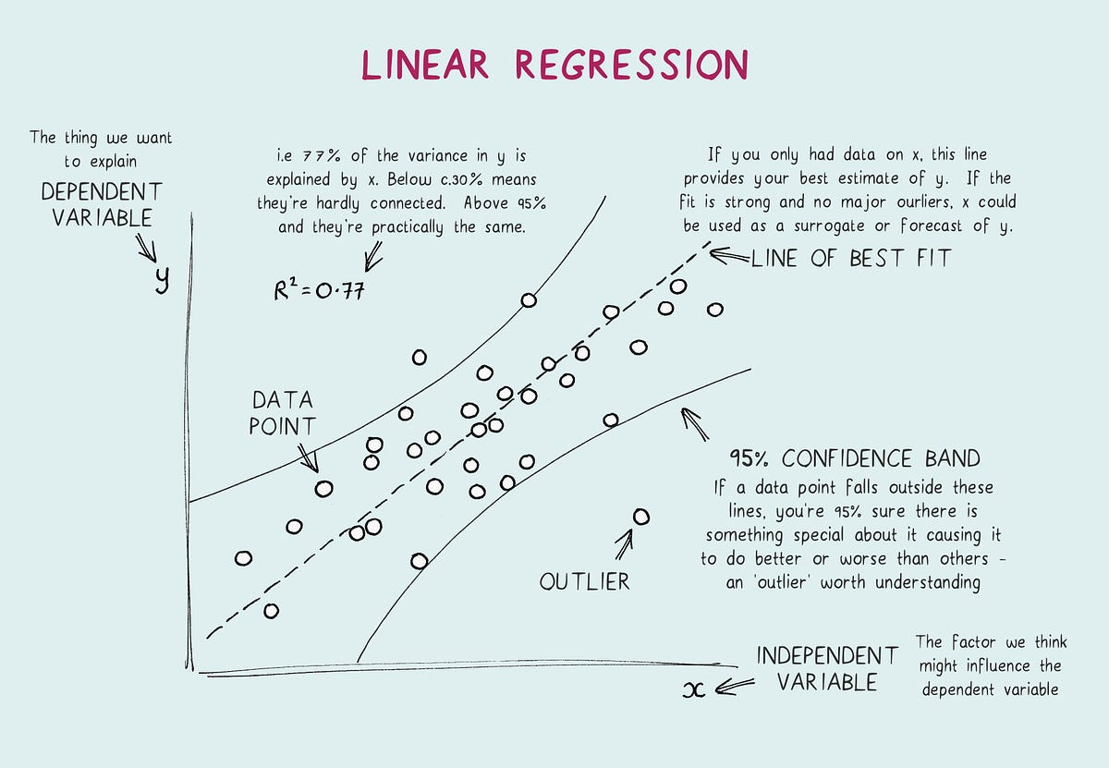

Figure 2.6 Linear Regression Model
2. Logistic Regression: Used for binary classification problems, logistic regression models the probability of a binary outcome based on one or more predictor variables. It is commonly used in churn prediction to estimate the likelihood that a customer will leave the service.
3. Decision Trees: These models split the data into subsets based on the value of input features, creating a tree-like structure. Each node represents a feature, each branch represents a decision rule, and each leaf represents an outcome. Decision trees are intuitive and easy to interpret.
4. Random Forests: An ensemble method that combines multiple decision trees to improve predictive accuracy and control over-fitting. By aggregating the predictions of many trees, random forests produce more robust and reliable predictions.
5. Support Vector Machines (SVMs): SVMs find the optimal hyperplane that separates data points of different classes in a high-dimensional space. They are effective in high-dimensional spaces and can handle non-linear decision boundaries using kernel functions.
6. Neural Networks: Comprising layers of interconnected nodes, neural networks are particularly powerful for capturing complex relationships in data. They are the foundation of deep learning models, which have achieved state-of-the-art performance in tasks such as image and speech recognition.
Unsupervised Learning
Unsupervised learning deals with unlabeled data, aiming to uncover hidden patterns or structures without explicit output labels. This type of learning is particularly useful for exploratory data analysis and dimensionality reduction.
1. Clustering: Algorithms like K-means, hierarchical clustering, and DBSCAN group data points into clusters based on similarity. Clustering can reveal natural groupings in the data, such as customer segments with similar behavior patterns.
2. Dimensionality Reduction: Techniques like Principal Component Analysis (PCA) and t-Distributed Stochastic Neighbor Embedding (t-SNE) reduce the number of features in a dataset while preserving its essential structure. This is useful for visualizing high-dimensional data and mitigating the curse of dimensionality.
3. Association Rule Learning: Methods like the Apriori algorithm and Eclat identify interesting relationships between variables in large datasets. These rules can be used for market basket analysis to discover items frequently bought together.
4. Anomaly Detection: Unsupervised methods can identify unusual data points that do not fit the general pattern of the dataset. Techniques such as isolation forests and autoencoders are used for fraud detection and identifying rare events.
Reinforcement Learning
Reinforcement learning (RL) is a type of machine learning where an agent learns to make decisions by interacting with an environment. The agent receives feedback in the form of rewards or penalties and aims to maximize the cumulative reward over time. This approach is inspired by behavioral psychology and is well-suited for sequential decision-making problems.
1. Markov Decision Processes (MDPs): MDPs provide a mathematical framework for modeling decision-making in environments where outcomes are partly random and partly under the control of the decision-maker. They define states, actions, transition probabilities, and rewards.
2. Q-Learning: A popular RL algorithm that aims to learn the value of action-state pairs, representing the expected future rewards of taking a particular action in a given state. Q-learning is used in applications like game playing and robotics.
3. Deep Q-Networks (DQNs): An extension of Q-learning that uses deep neural networks to approximate the Q-values for high-dimensional state spaces. DQNs have been successfully applied in complex environments, such as playing Atari games.
4. Policy Gradient Methods: These methods optimize the policy directly by adjusting the parameters of a policy function. Algorithms like REINFORCE and Proximal Policy Optimization (PPO) are used in tasks requiring continuous action spaces, such as robotic control and real-time strategy games.

2.7 Concept of Feature Selection and Feature Engineering
Feature selection and engineering are critical steps in the machine learning pipeline. They involve identifying and creating the most relevant and informative features (variables) from raw data to improve model performance, interpretability, and generalization. Effective feature selection and engineering can significantly impact the success of machine learning models, particularly in complex tasks like customer churn prediction in the telecommunications industry.

2.7.1 Methods of Feature Selection
1. Filter Methods: Filter methods evaluate the relevance of each feature independently of the model. Common techniques include statistical tests (e.g., chi-square, ANOVA), correlation coefficients, and mutual information. These methods are computationally efficient and provide a good first step in the feature selection process.
2. Wrapper Methods: Wrapper methods evaluate the performance of a subset of features by training a model and measuring its accuracy. Techniques like forward selection, backward elimination, and recursive feature elimination (RFE) are commonly used. Although more computationally intensive than filter methods, wrapper methods often yield better performance by considering feature interactions.
3. Embedded Methods: Embedded methods perform feature selection during the model training process. Techniques such as Lasso (Least Absolute Shrinkage and Selection Operator) and Ridge regression add regularization terms to the loss function, penalizing the inclusion of less important features. Tree-based methods like random forests and gradient boosting also provide feature importance scores as part of the model training process.

2.7.2 Feature Engineering Techniques in Customer Churn Prediction
In customer churn prediction, feature engineering can significantly enhance model performance by creating features that capture the nuanced behavior of customers. Some common techniques include:
1. Customer Engagement Metrics: Creating features that quantify customer engagement, such as the number of calls made, data usage, and frequency of customer service interactions, can provide insights into customer satisfaction and likelihood of churn.
2. Behavioral Patterns: Analyzing patterns in service usage over time, such as changes in data consumption or call duration, can help identify early signs of churn. For example, a sudden drop in usage might indicate dissatisfaction.
3. Derived Features: Creating new features from existing ones, such as the ratio of different service usages (e.g., call-to-data usage ratio), can reveal more about customer preferences and potential churn risk.
4. Temporal Features: Incorporating temporal aspects, such as the time since the last customer interaction or the duration of the current contract, can help capture trends and seasonality in churn behavior.

2.8 Common Features Used in Churn Prediction
Customer churn prediction involves identifying customers who are likely to leave a service provider. Accurate prediction relies heavily on selecting the right features that reflect customer behavior, preferences, and satisfaction levels. Common features used in churn prediction include usage patterns, customer demographics, and billing information, among others. These features help build models that can effectively identify at-risk customers and enable targeted retention strategies.
Usage Patterns
1. Call and Data Usage: One of the most significant predictors of churn is how customers use their telecommunication services. Metrics like the number of calls made, call duration, data usage volume, and frequency of service usage can provide insights into customer engagement and satisfaction. For instance, a sudden drop in call duration or data usage might indicate dissatisfaction or a shift to a competitor's service.
2. Service Interactions: The frequency and nature of interactions with customer service can be indicative of churn risk. High volumes of complaint calls or frequent requests for support can signal dissatisfaction. Conversely, proactive service interactions, such as seeking information about new services, might indicate customer engagement.
3. Usage Trends: Analyzing trends over time can help detect changes in behavior that precede churn. For example, if a customer's usage gradually declines over several months, it might indicate that they are considering switching providers. Seasonal variations and patterns in usage can also be important; for example, higher usage during certain times of the year might be typical for some customers, and deviations from this pattern could be significant.
4. Feature Adoption: The adoption of new features or services can indicate customer satisfaction and engagement. Customers who frequently try out new services or upgrade their plans are generally more engaged and less likely to churn. Conversely, those who do not adopt new features might be at a higher risk of leaving.
Customer Demographics
1. Age and Gender: Demographic factors such as age and gender can influence churn behavior. Different age groups and genders may have varying preferences and levels of satisfaction with services. For example, younger customers might prioritize data services for social media and streaming, while older customers might value call quality more.
2. Location: Geographic information can provide insights into service availability and competition. Customers in urban areas might have more alternatives and be more likely to churn if they experience poor service quality. Rural customers might have fewer options and different usage patterns, affecting their churn behavior.
3. Income and Occupation: Socioeconomic status can affect customers' ability to pay for services and their sensitivity to price changes. Higher-income customers might be less price-sensitive and more focused on service quality, while lower-income customers might be more likely to churn due to financial constraints.
4. Education Level: Education can impact customers' awareness of available services and their propensity to seek better deals. More educated customers might be more proactive in exploring alternatives and switching providers if they find better offers.
Billing Information
1. Payment History: Timely payments and the presence of overdue bills can indicate financial stability and customer satisfaction. Customers who frequently miss payments or have a history of overdue bills might be at a higher risk of churning due to financial difficulties or dissatisfaction with the service.
2. Billing Cycle and Amount: The frequency and amount of bills can affect churn risk. Customers with high monthly bills might be more inclined to switch providers if they perceive they are not getting value for their money. Additionally, those on longer billing cycles might be less engaged and more likely to churn.
3. Payment Method: The method of payment (e.g., credit card, direct debit, prepaid) can provide insights into customer preferences and financial behavior. Prepaid customers might churn more frequently due to the flexibility to switch providers without penalty, while postpaid customers with long-term contracts might have lower churn rates.
4. Discounts and Promotions: The use of discounts and promotional offers can affect customer retention. Customers who frequently take advantage of promotions might be more price-sensitive and prone to churn if these offers are discontinued.
Other Relevant Features
1. Contract Type and Duration: The type and length of the contract can significantly influence churn behavior. Customers on long-term contracts with penalties for early termination might be less likely to churn compared to those on month-to-month plans. The approach of contract renewal dates can also be a critical period for churn risk.
2. Customer Satisfaction Scores: Surveys and feedback mechanisms that measure customer satisfaction can provide direct insights into churn risk. Low satisfaction scores are often correlated with higher churn rates. Net Promoter Score (NPS) and Customer Satisfaction Score (CSAT) are commonly used metrics.
3. Service Quality Metrics: Network performance indicators, such as call drop rates, data speed, and network coverage, are crucial for understanding customer satisfaction. Poor service quality can drive customers to switch providers. Monitoring these metrics can help identify at-risk customers.
4. Engagement with Marketing Campaigns: Interaction with marketing efforts, such as opening emails, clicking on ads, or participating in loyalty programs, can indicate customer engagement. Higher engagement levels generally correlate with lower churn rates, as these customers feel more connected to the brand.
5. Churn History: Historical churn behavior can be predictive of future churn. Customers who have previously churned and returned may exhibit patterns that indicate higher churn risk. Understanding these patterns can help tailor retention strategies.
6. Competitor Activity: Market conditions and competitor actions, such as new service launches or aggressive pricing strategies, can influence churn. Customers might switch providers in response to better offers or innovative services from competitors.
7. Customer Tenure: The length of time a customer has been with the service provider can impact churn behavior. Long-term customers might have higher loyalty and lower churn rates, while new customers might be more prone to switch providers if their initial experience is unsatisfactory.
Integrating Features for Churn Prediction Models
1. Feature Engineering: Combining and transforming raw data into meaningful features is crucial for building effective churn prediction models. Techniques such as creating interaction terms, aggregating data over different time periods, and scaling features to a common range can enhance model performance.
2. Feature Selection: Selecting the most relevant features helps in building models that are both accurate and interpretable. Techniques like correlation analysis, mutual information, and recursive feature elimination (RFE) can identify the features that contribute most to predicting churn.
3. Modeling Approaches: Various machine learning algorithms can be used to predict churn, including decision trees, random forests, logistic regression, and neural networks. The choice of algorithm depends on the complexity of the data, the importance of interpretability, and the computational resources available.
Model Evaluation Metrics
Evaluating the performance of machine learning models is crucial to ensure their effectiveness, especially in sensitive applications like churn prediction in the telecommunications industry. Various metrics and techniques are used to assess how well a model predicts churn, including accuracy, precision, recall, F1-score, ROC-AUC, and cross-validation methods.

2.9 Analysis of Model Evaluation Metrics and Techniques
Accuracy, Precision, Recall, and F1-Score
1. Accuracy
Accuracy is the simplest metric and represents the ratio of correctly predicted instances to the total instances. It is calculated as follows:
$$Accuracy=\frac{True Positives \left(TP\right)+True Negatives (TN)}{Total Instances}$$
While accuracy provides a general idea of the model's performance, it can be misleading in cases of class imbalance, which is common in churn prediction where the number of non-churning customers often exceeds the number of churners.
2. Precision
Precision measures the ratio of correctly predicted positive instances to the total predicted positive instances. It is particularly useful when the cost of false positives is high. For churn prediction, it indicates the proportion of predicted churners who actually churned.
$$Precision=\frac{True Positives (TP)}{True Positives (TP)+False Positives (FP)}$$
High precision indicates a low false positive rate, which means fewer non-churning customers are incorrectly identified as churners.
3. Recall
Recall, also known as sensitivity or true positive rate, measures the ratio of correctly predicted positive instances to all actual positive instances. It is critical when the cost of false negatives is high, meaning it captures how well the model identifies actual churners.
$$Recall=\frac{True Positives (TP)}{True Positives (TP) + False Negatives (FN)}$$
4. F1-Score
The F1-score is the harmonic mean of precision and recall, providing a single metric that balances both. It is particularly useful when there is a trade-off between precision and recall.
$$F1 Score=2×\frac{Precision × Recall}{Precision + Recall}$$
A high F1-score indicates that the model has both high precision and high recall, which is crucial for effective churn prediction.
ROC-AUC (Receiver Operating Characteristic - Area Under Curve)
The ROC curve is a graphical representation of a model's diagnostic ability. It plots the true positive rate (recall) against the false positive rate (1-specificity) at various threshold settings. The Area Under the ROC Curve (AUC) quantifies the overall ability of the model to discriminate between positive and negative classes.
1. ROC Curve
The ROC curve shows the trade-off between sensitivity (recall) and specificity (true negative rate). A model with a curve closer to the top-left corner indicates better performance.
2. AUC
The AUC score ranges from 0 to 1, with a higher value indicating better performance. An AUC of 0.5 suggests a model with no discriminatory power, equivalent to random guessing, while an AUC of 1 indicates perfect discrimination.
$$AUC =\int_{0}^{1}{ROC\left(t\right)}dt$$
AUC is particularly useful for evaluating models when there is a class imbalance, as it provides a single value to compare different models.
Cross-Validation Techniques
Cross-validation is a robust technique to evaluate the generalization of a model by partitioning the data into multiple subsets and testing the model on different subsets. Common cross-validation methods include:
1. K-Fold Cross-Validation
In k-fold cross-validation, the dataset is randomly partitioned into k equally sized folds. The model is trained on k-1 folds and tested on the remaining fold. This process is repeated k times, with each fold used as the test set once. The final evaluation metric is the average of the metrics from each fold.
$$CV Accuracy=\frac{1}{k}\sum_{i=1}^{k}{{Accuracy}_{i}}$$
K-fold cross-validation helps mitigate over-fitting and provides a more accurate estimate of model performance on unseen data.
2. Stratified K-Fold Cross-Validation
Stratified k-fold cross-validation ensures that each fold has the same proportion of classes as the original dataset. This is particularly important for imbalanced datasets, like churn prediction, to maintain the distribution of churners and non-churners in each fold.
3. Leave-One-Out Cross-Validation (LOOCV)
LOOCV is a special case of k-fold cross-validation where k is equal to the number of data points in the dataset. The model is trained on all data points except one, which is used as the test set. This process is repeated for each data point. While LOOCV provides an unbiased estimate of model performance, it is computationally expensive for large datasets.
4. Holdout Method
The holdout method splits the dataset into two parts: a training set and a test set. The model is trained on the training set and evaluated on the test set. While simple, this method can be sensitive to how the data is split, and it does not provide as robust an estimate of model performance as cross-validation.
5. Bootstrap Method
The bootstrap method involves sampling the dataset with replacement to create multiple training sets. The model is trained on each bootstrap sample and evaluated on the remaining data points. This technique can provide estimates of the variance of model performance.

2.10 Challenges and Limitations in Churn Prediction
Predicting customer churn in the telecommunications industry presents several challenges and limitations that can significantly impact the accuracy and effectiveness of churn prediction models. These challenges include data quality and availability, model interpretability, and handling class imbalance.
Data Quality and Availability
1. Incomplete and Inconsistent Data: One of the primary challenges in churn prediction is ensuring high-quality data. Data collected from various sources may be incomplete or inconsistent. For instance, customer data might have missing values for important attributes like billing information or usage patterns. Incomplete data can lead to inaccurate predictions, as the model may not have enough information to accurately classify customers as likely churners or non-churners (Xu et al., 2020).
2. Data Integration from Multiple Sources: Telecommunications companies often collect data from multiple sources such as call records, billing systems, customer service interactions, and social media. Integrating this data into a single cohesive dataset is complex and can introduce errors if not managed properly. Discrepancies between different data sources can lead to inconsistencies that affect the model’s performance (Moro et al., 2019).
3. Timeliness of Data: The predictive power of churn models is highly dependent on the timeliness of the data. Data that is outdated may not accurately reflect current customer behavior. For instance, a customer’s usage patterns may have changed significantly since the data was collected, leading to incorrect predictions. Ensuring real-time or near-real-time data availability is crucial for accurate churn prediction (Amin et al., 2019).
4. Data Privacy and Security: Collecting and utilizing customer data for churn prediction raises privacy and security concerns. Companies must ensure compliance with data protection regulations such as the General Data Protection Regulation (GDPR) in Europe or the Nigeria Data Protection Regulation (NDPR) in Nigeria. These regulations impose strict requirements on data collection, storage, and usage, which can limit the availability of data for churn prediction models (Kantarcioglu et al., 2020).
Model Interpretability
1. Complexity of Machine Learning Models: Advanced machine learning models like deep learning and ensemble methods are often seen as "black boxes" due to their complexity. These models can capture intricate patterns in the data, but their decision-making process is not easily interpretable. For instance, a neural network with multiple hidden layers can provide accurate predictions but understanding why a particular customer is predicted to churn can be challenging (Rudin, 2019).
2. Regulatory Requirements: In industries like telecommunications, regulatory bodies may require explanations for automated decisions, especially those affecting customer relations. Lack of interpretability in churn prediction models can make it difficult for companies to comply with these regulations. Transparent models, such as decision trees, are preferred in such scenarios, but they may not always provide the best predictive performance (Molnar, 2020).
3. Trust and Adoption by Stakeholders: For churn prediction models to be effectively used by marketing and customer service teams, they need to be trusted by these stakeholders. If the model's predictions and underlying logic are not transparent, stakeholders may be hesitant to rely on the model's recommendations. Ensuring that the models are interpretable can help build trust and facilitate adoption (Lipton, 2018).
Handling Class Imbalance
1. Imbalance in Churn Data: Customer churn datasets are often imbalanced, with a small percentage of customers actually churning compared to the majority who stay. This imbalance poses a significant challenge for machine learning models, which may become biased towards the majority class and fail to accurately identify churners (He and Garcia, 2019).
2. Impact on Model Performance: Standard machine learning algorithms tend to perform poorly on imbalanced datasets because they assume an equal distribution of classes. This can result in high accuracy but low recall for the minority class (churners). In churn prediction, the goal is to identify as many churners as possible, making recall a critical metric (Krawczyk, 2016).

2.11 Case Studies and Applications
The field of customer churn prediction has seen various successful implementations and research endeavors in the telecommunications industry. These case studies offer valuable insights into effective strategies for managing customer churn and highlight lessons learned from real-world applications of machine learning techniques. This section reviews notable research and case studies, focusing on their methodologies, outcomes, and implications for future churn prediction efforts.

2.11.1 Review of Case Studies in Telecommunications
1. Case Study 1: Vodafone’s Churn Prediction Model
Vodafone, a leading global telecommunications provider, implemented a churn prediction model to better understand and mitigate customer attrition. The model utilized a range of machine learning techniques, including logistic regression, decision trees, and random forests, to predict customer churn based on features such as customer demographics, service usage patterns, and billing information (Kshetri, 2017).
Vodafone’s approach focused on integrating data from multiple sources, including customer service interactions, billing records, and network usage data. They employed ensemble methods to combine the predictions from various models, improving the accuracy of their churn forecasts. The key findings from Vodafone’s experience include the importance of data integration and the effectiveness of ensemble methods in achieving high predictive performance. The company successfully used these insights to develop targeted retention strategies, resulting in a reduction in churn rates by approximately 10% (Kshetri, 2017).
2. Case Study 2: AT&T’s Use of Machine Learning for Churn Prediction
AT&T, another major player in the telecommunications industry, implemented a machine learning-based churn prediction system to address high customer attrition rates. Their model employed techniques such as support vector machines (SVM) and gradient boosting to analyze customer behavior and predict churn risk (Nguyen and Simkin, 2017).
AT&T’s system was designed to analyze large volumes of data, including customer feedback, service usage metrics, and transaction history. The model incorporated feature engineering techniques to extract relevant features from raw data, such as changes in service usage and customer complaints. The application of machine learning methods allowed AT&T to identify at-risk customers more accurately and implement targeted retention initiatives. As a result, AT&T saw a significant improvement in their customer retention efforts and a reduction in churn rates by approximately 12% (Nguyen and Simkin, 2017).
3. Case Study 3: T-Mobile’s Predictive Analytics for Churn Management
T-Mobile, a leading telecommunications provider in the United States and Europe, implemented a predictive analytics model to manage customer churn. T-Mobile’s model utilized various machine learning algorithms, including decision trees, random forests, and neural networks, to predict churn and identify key factors influencing customer decisions (Verhoef et al., 2016).
The study revealed that the integration of predictive analytics into T-Mobile’s customer management processes led to the development of effective retention strategies, such as personalized offers and targeted marketing campaigns. T-Mobile’s success in reducing churn rates by 15% demonstrated the value of advanced analytics in managing customer relationships and highlighted the importance of continuous model refinement and feature selection (Verhoef et al., 2016).
4. Case Study 4: O2’s Customer Retention Strategies
O2, a major telecommunications company in the UK and Ireland, employed a churn prediction model using machine learning techniques such as logistic regression and random forests. The focus of O2’s model was on understanding customer churn patterns and developing retention strategies based on predictive insights (Li and Liu, 2018).
O2’s approach involved analyzing customer data to identify churn triggers, such as service disruptions and billing issues. The company used the insights gained from the churn prediction model to develop proactive retention strategies, including targeted promotions and improved customer service. O2’s implementation of these strategies led to a 7% decrease in churn rates and provided valuable lessons on the importance of customer-centric retention efforts (Li and Liu, 2018).
Successful Implementations and Lessons Learned
The case studies reviewed highlight several key lessons for successful churn prediction implementations:
1. Importance of Data Quality and Integration: All case studies emphasize the necessity of high-quality, integrated data for effective churn prediction. Ensuring data completeness, consistency, and timeliness is critical for developing accurate models and implementing successful retention strategies (Kshetri, 2017; Nguyen and Simkin, 2017).
2. Value of Ensemble Methods and Advanced Algorithms: The use of ensemble methods and advanced machine learning algorithms, such as random forests and gradient boosting, has been a common theme in successful churn prediction models. These techniques provide robust performance and help improve prediction accuracy by combining the strengths of multiple models (Nguyen and Simkin, 2017; Verhoef et al., 2016).
3. Role of Feature Engineering: Effective feature engineering is crucial for developing accurate churn prediction models. The case studies demonstrate that selecting and engineering relevant features, such as service usage patterns and customer complaints, can significantly enhance model performance (Li and Liu, 2018; Verhoef et al., 2016).
4. Need for Continuous Model Improvement: Successful churn prediction efforts require ongoing model refinement and adaptation to changing customer behaviors. Regular updates and adjustments to the models ensure that they remain effective in predicting churn and supporting retention strategies (Kshetri, 2017).
5. Effective Use of Predictive Insights: Translating predictive insights into actionable retention strategies is essential for reducing churn. The case studies illustrate that companies can leverage model predictions to develop targeted marketing campaigns, personalized offers, and improved customer service (Nguyen and Simkin, 2017; Li and Liu, 2018).

2.12 Theoretical Design Framework
Understanding customer churn in the telecommunications industry requires a multifaceted theoretical framework that integrates insights from customer behavior theories, machine learning theories, and information systems theory. This comprehensive approach not only aids in predicting churn but also in developing effective strategies to mitigate it. Each component of this framework contributes uniquely to the overall understanding and solution of the churn problem.

2.12.1 Customer Behavior Theories
Customer behavior theories offer critical insights into the motivations and decisions of customers, which are essential for understanding churn. The Expectancy Disconfirmation Theory suggests that customer satisfaction is influenced by the discrepancy between expected and actual service performance. When actual performance exceeds expectations, customers are satisfied and more likely to remain loyal; when it falls short, dissatisfaction can lead to churn (Oliver, 2019).
The Theory of Planned Behavior explains that customer retention is influenced by attitudes towards the service, subjective norms, and perceived behavioral control. This theory highlights the importance of understanding customers' attitudes and social influences to predict their likelihood of remaining with a service (Ajzen, 1991). Furthermore, the Customer Loyalty Theory posits that factors such as trust, commitment, and satisfaction are crucial determinants of loyalty. Building strong, trust-based relationships with customers can significantly reduce churn rates (Dick and Basu, 1994).
The Switching Costs Theory suggests that the perceived costs associated with switching to another provider, including financial, time, and psychological costs, influence churn behavior. High switching costs can act as a deterrent to churn, even when customers are not fully satisfied (Burnham, Frels, and Mahajan, 2003).

2.12.2 Machine Learning Theories
Machine learning theories are essential for developing predictive models for churn. Supervised Learning Theory involves training models on labeled data to predict outcomes on new data, which is a common approach in churn prediction. Techniques such as decision trees, random forests, support vector machines (SVM), and neural networks are used to identify patterns in historical customer data that indicate a high risk of churn (Bishop, 2006).
Unsupervised Learning Theory is also relevant, particularly for clustering customers into segments based on their behavior patterns without predefined labels. This can help identify groups of customers with similar characteristics and churn risks (Hastie, Tibshirani, and Friedman, 2009). Reinforcement Learning Theory, which involves learning optimal strategies through interactions with the environment, can be applied to develop adaptive retention strategies that evolve based on customer behavior (Sutton and Barto, 2018).
Feature Selection and Engineering Theory emphasizes the importance of identifying the most relevant features from the data that contribute to accurate predictions. In churn prediction, features such as customer demographics, usage patterns, and billing information are critical. Effective feature selection enhances model performance by focusing on the most predictive variables (Guyon and Elisseeff, 2003).

2.12.3 Information Systems Theory
Information Systems Theory provides a broader context for integrating and utilizing predictive models within organizations. The Technology Acceptance Model (TAM) explains the adoption of new technologies based on perceived ease of use and perceived usefulness. For churn prediction models, ensuring that these systems are user-friendly and demonstrate clear benefits is crucial for adoption by telecommunications companies (Davis, 1989).
The Decision Support Systems (DSS) Theory describes how information systems can support decision-making processes by providing timely, accurate, and relevant information. DSS can integrate churn prediction models to help managers develop targeted retention strategies and make informed decisions.
The Information Quality Theory emphasizes the importance of high-quality data for reliable predictions. Ensuring data accuracy, completeness, consistency, and timeliness is essential for effective churn prediction models (Wang and Strong, 1996). Robust data management practices are necessary to maintain the integrity and utility of predictive models in telecommunications.

2.13 Summary of Related Literature
Author(s) & Year | Objectives | Methodology | Results | Strengths | Weaknesses | Identified Gaps
Nguyen et al. (2020) | To identify key predictors of customer churn in telecoms using machine learning. | Random Forest, Logistic Regression, and KNN on telecom data from Vietnam. | Random Forest achieved 80% accuracy, highlighting call duration and data usage as key churn predictors. | Used diverse ML algorithms for comparison and validation. | Dataset limited to one telecom operator and specific geographic region. | Lack of analysis on socio-economic factors affecting churn.
Abdulkareem et al. (2019) | To analyze the impact of customer service on churn rates in Nigerian telecom industry. | Survey-based analysis with 500 respondents from Lagos State. | Poor customer service was found to increase churn probability by 60%. | Real-world insights from customers. | Limited sample size and subjective responses prone to bias. | No predictive models to validate findings quantitatively.
Sharma & Gupta (2018) | To evaluate how prepaid and postpaid plans influence customer loyalty. | Chi-square tests on billing data from 2 telecom providers in India. | Postpaid customers showed 30% higher retention rates than prepaid. | Clear segmentation of subscribers by plan type. | Did not consider demographic or service usage variables. | No machine learning analysis to predict churn.
Oladipo et al. (2021) | To assess the role of data quality on churn prediction models. | Data preprocessing techniques and Logistic Regression on Nigerian telecom datasets. | Improved data cleaning enhanced model accuracy from 72% to 78%. | Demonstrated importance of data quality for model reliability. | Limited focus on feature engineering or other ML techniques. | No exploration of advanced ML models like Random Forest or Neural Networks.
Chen et al. (2020) | To improve churn prediction accuracy through ensemble learning. | Used Gradient Boosting and AdaBoost on telecom data. | Ensemble methods achieved 85% accuracy, outperforming single algorithms. | Innovative use of ensemble techniques. | Computational complexity and lack of real-world application testing. | Did not test model generalizability across different markets.

Table 2.13 Conclusion and Gaps for Current Study
- Predictive Model Scope: Previous studies either relied on basic machine learning algorithms or lacked comparison across models, leaving room for advanced methods like Random Forest and XGBoost in a Nigerian context.
- Data Generalizability: Most studies were limited to single operators or specific regions, reducing the generalizability of results.
- Influential Factors: Socio-economic and behavioral factors are often underexplored in the Nigerian telecom sector.
- Performance Evaluation Metrics: Few studies comprehensively evaluated models using multiple metrics (accuracy, precision, recall, F1 score, etc.).
These gaps justify the need for this study to employ robust machine learning models, evaluate them comprehensively, and focus on a broader dataset encompassing MTN and Airtel to provide actionable insights for the Nigerian telecom industry.

CHAPTER THREE

SYSTEM ANALYSIS AND DESIGN METHODOLOGY

3.1 Chapter Overview
The methodology chapter outlines the systematic approach adopted for predicting customer churn in the telecommunications industry using machine learning models. This chapter provides a comprehensive overview of the research design, data collection methods, data preprocessing steps, feature selection and engineering techniques, development of machine learning models, model training and evaluation procedures, and the comparison of models.

3.2 Research Design
This study employs a descriptive and explanatory research design. The descriptive aspect aims to quantify the extent of customer churn in the telecommunications industry by analyzing historical churn data (Abreu et al.,2016). The explanatory component seeks to understand the underlying factors influencing churn through predictive modeling, which helps in identifying patterns and factors associated with customer attrition. This dual approach allows for a comprehensive analysis, providing actionable insights that telecommunications companies can leverage to reduce churn rates and enhance customer retention.

3.3 Proposed System Design Methodology
The proposed framework for customer churn prediction in Nigeria’s telecommunications industry using machine learning models is shown in Figure 3.1. The framework follows a structured architecture with the following key components:
- Data Collection: Gathers customer data (demographics, usage, billing) from MTN and Airtel.
- Data Preprocessing: Cleans and transforms raw data, handles missing values, encodes categorical variables, and normalizes numerical features.
- Feature Selection: Identifies the most important variables (e.g., customer tenure, spending patterns) using techniques like correlation analysis.
- Model Training: Utilizes multiple machine learning models, including Decision Tree, Random Forest, XGBoost, and SVM, trained on 80% of the data.
- Model Evaluation: Assesses model performance using metrics like accuracy, precision, recall, and F1-score with the remaining 20% of data.
- Churn Prediction: Predicts customer churn probability for real-time decision-making.
- Retention Strategy: Provides actionable insights to reduce churn, such as personalized offers or improved customer service.
- Feedback Loop: Continuously refines models with new data for improved accuracy.
This architecture integrates data preprocessing, machine learning, and actionable retention strategies to effectively predict and reduce customer churn.

Telecom Customers Data Profile

Data Preprocessing
Data Cleaning
Data Encoding
Data Normalization
Data Splitting
Testing Data
Training Data
Transformed data
Raw
data
Model Building
Decision Tree
Random Forest
SVM
XGBoost
Learned Model
Model Evaluation
&
Visualization
Churn Prediction
Retention Strategy

Figure 3.3 Proposed ML-Based Framework for Customer Churn Prediction
Data Collection
Data Sources:
The data source for this study was the customer database of a telecommunications company, specifically MTN or Airtel. This database contained detailed records of customer interactions, usage patterns, and churn history. Additionally, a public dataset from the UCI Machine Learning Repository was used to supplement the primary data, providing a more robust analysis and enhancing the generalizability of the findings.
Dataset Composition:
The dataset comprised customer demographics (e.g., age, gender, subscription type), service usage data (e.g., call duration, data consumption), billing information (e.g., monthly spending), and churn status (whether a customer had churned or remained). The dataset contained 6,915 customer records, with features selected based on their relevance to churn prediction.
Data Collection Methods:
Data was extracted from the telecommunications company’s customer portals, and public datasets were accessed via online repositories. The selected features were pertinent to churn prediction, ensuring a comprehensive dataset aligned with the study’s objectives.
Ethical Considerations:
Informed consent was obtained for any primary data collected. Data anonymization techniques were applied to safeguard customer privacy and comply with data protection regulations such as GDPR (Bryman & Bell, 2015).

3.4 Data Preprocessing
Min-Max Scaling and Normalization:
- Identify Numerical Features: Select the numerical features in the dataset that require scaling (e.g., monthly spending, call duration).
- Calculate Min and Max Values: For each numerical feature, determine the minimum and maximum values across all data points.
Min-Max Scaling is a normalization technique that rescales each feature (column) of the data to a fixed range, typically between 0 and 1. It is denoted as follows:
$$x^{'}= \frac{x− x_{min}}{x_{max}− x_{min}}$$
where, $x$ is the original value, $x_{min}$ is the minimum value in column, $x_{max}$ is the maximum value in column, and $x^{'}$ is the scaled value (between 0 and 1).

- Check for Data Consistency: Ensure that the scaled data is consistent and within the specified range, without outliers affecting the scaling process.
- Use Scaled Data: The normalized data is now ready for input into machine learning models, ensuring that all features are on a comparable scale.

3.5 Feature Selection and Feature Engineering
Techniques Used for Feature Selection:
In this study, feature selection was performed using a combination of domain knowledge and statistical methods to identify the most influential factors impacting churn prediction. Key techniques included:
Correlation Analysis: A correlation matrix was computed to identify relationships between features. Strong correlations between independent variables (e.g., age, monthly spend) and the target variable (churn) were considered significant, as they indicate a potential impact on churn rates. Features with weak or no correlation to the target variable were excluded to simplify the model and reduce noise.
Chi-Square Test: For categorical data, the chi-square test was applied to evaluate the independence between each feature and the churn outcome. Features with a low p-value (typically < 0.05) were considered significant, as they have a strong association with churn. Non-significant features were removed to avoid redundancy.
Domain Knowledge: Features such as customer demographics (age, gender), service usage (monthly spend, call frequency), and billing information were prioritized based on their relevance to customer churn. Expert knowledge of the telecommunications industry helped confirm the importance of these features.
By using these techniques, features such as customer age, plan type, and frequency of service usage were deemed significant, while variables like customer region (if unrelated to service quality or pricing) might have been excluded due to limited predictive power. This process ensures that only the most relevant features are retained for effective churn prediction.

3.6 Development of Machine Learning Models
Selection of Machine Learning Models: This study will focus on key models such as Extreme Gradient Boosting (XGBoost), Support Vector Machine, Random Forest and Decision Tree. These models are chosen for their simplicity, effectiveness, and interpretability in predicting churn.
Justification for Chosen Models: SVM is favored for its simplicity and ease of interpretation, using the hyperplane to split the feature space, allowing for straightforward insights into churn predictors. Decision trees are selected for their ability to provide clear decision rules and visual representation of decision paths. Random forests are included for their enhanced prediction accuracy through ensemble learning, which combines multiple decision trees to improve performance (Friedman, Hastie, and Tibshirani, 2021).
Implementation Details: The implementation of these models will be done using software tools and libraries such as Python’s scikit-learn, which provides robust machine learning functionalities and ease of use. This choice ensures that the implementation is both efficient and accessible.

3.7 ML Model Training and Evaluation
Training Process for Each Model: Each model will be trained using a training dataset. Hyperparameters will be optimized through grid search, which systematically evaluates different parameter combinations to enhance model performance.
Evaluation Metrics Used: Model performance will be evaluated using essential metrics such as accuracy, precision, recall, and F1-score. These metrics provide a comprehensive assessment of each model’s effectiveness in predicting churn and its ability to handle imbalanced data.
Cross-Validation and Hyperparameter Tuning: Cross-validation techniques, such as k-fold cross-validation, will be employed to ensure the generalizability of the models. Hyperparameter tuning will be conducted to find the optimal parameters that maximize model performance, ensuring that the models perform well on unseen data.
Mathematical Expressions for Evaluation Metrics
1. Accuracy
Accuracy measures the ratio of correctly predicted instances to the total number of instances:
$$A=\frac{TP+TN}{TP+TN+FP+FN}$$

Where:
- TP: True Positives
- TN: True Negatives
- FP: False Positives
- FN: False Negatives
2. Precision
Precision (also called Positive Predictive Value) measures the ratio of correctly predicted positive observations to the total predicted positives:
$$P =\frac{TP}{TP+FP}$$
3. Recall
Recall (also called Sensitivity or True Positive Rate) measures the ratio of correctly predicted positive observations to the actual positives:
$$R=\frac{TP}{TP+FN}$$
4. F1-Score
F1-Score is the harmonic mean of precision and recall, providing a balanced measure, especially for imbalanced datasets:
$$F1 Score=\frac{P∗R}{P+R}$$
These metrics collectively provide a thorough evaluation of model performance, particularly in churn prediction scenarios involving class imbalance.

3.8 Comparison of Models and Primary Dataset
Criteria for Comparison:
Models were evaluated based on key performance metrics: accuracy, precision, recall, and F1-score. Accuracy measured overall correctness, while precision focused on the proportion of correctly predicted positive cases. Recall indicated the model’s ability to identify all actual churners, and the F1-score balanced precision and recall, particularly useful for imbalanced datasets. Interpretability was also assessed to ensure practical applicability, with models like Decision Trees offering insights into customer churn behavior.
Statistical Tests Used for Comparison:
A paired t-test was applied to compare model performance. This test evaluated the difference in performance metrics (e.g., accuracy or F1-score) between model pairs on the same dataset. Each observation represented a model’s prediction versus actual outcomes. If the p-value was less than 0.05, the difference was statistically significant, confirming that one model outperformed the other consistently. This approach ensured reliable and data-driven model selection.
Primary Dataset
The primary dataset for this study was collected directly from a telecommunications company (e.g., MTN or Airtel) in Nigeria. This dataset includes customer records, such as demographics, service usage patterns, billing information, and churn history. The data was sourced from internal company databases to ensure it is specific, detailed, and relevant to the study objectives.
The respondents for this study were selected using a purposive sampling method. This approach focused on customers who have interacted with the telecommunications services over a specific period, with a particular emphasis on those who exhibited characteristics associated with churn (e.g., service complaints, frequent changes in plans). The selection was based on available churn data, ensuring that a meaningful comparison between churned and non-churned customers could be made.

3.9 Instrument Validation and Reliability Assessment
The survey instrument (questionnaire) used to collect customer opinions on churn-related factors was validated by a panel of experts in telecommunications and machine learning. These experts reviewed the instrument for clarity, relevance, and comprehensiveness in relation to the study's objectives. Additionally, feedback from a small group of pilot respondents was incorporated to refine the instrument before full-scale deployment.
To ascertain the reliability of the survey instrument, a pilot test was conducted with a sample group of 30 respondents from the target population. The test yielded a Cronbach’s Alpha coefficient of 0.85, indicating a high level of internal consistency. This reliability score confirms that the instrument consistently measures the intended variables without significant measurement error.

CHAPTER FOUR

SYSTEM IMPLEMENTATION

4.1 Chapter Overview
This chapter presents the analysis and interpretation of data collected from 2,576 respondents sampled from the Nigerian telecommunications sector, focusing on MTN and Airtel customers. The analysis aims to explore key factors that influence customer churn and compare churn rates between these two dominant service providers.
The data were obtained electronically through structured questionnaires administered via Google Forms. After data cleaning (missing values removal, etc.), the sample size was refined to 1, 383 respondents, as other entries were excluded due to incomplete or inconsistent responses. The remaining data provides a robust foundation for analyzing key demographic information, customer satisfaction levels, subscription patterns, and usage behaviors.
By examining these responses, the study seeks to uncover significant patterns contributing to customer churn and assess how these factors align with the research objectives. This chapter also offers a detailed breakdown of the findings, including descriptive statistics and the relationship between various factors such as age, gender, subscription type, and monthly spending with customer churn. The goal is to generate insights that can help reduce churn rates and improve customer retention in Nigeria's highly competitive telecommunications industry.
Tables 4.1.1 - 4.1.10 captures the demographic profiles of the customers indicating the various frequency and percentage distribution of the considered profiles of the respondents. A detailed analysis is presented in preceding sections.

Table 4.1.1 Age Distribution of Respondents
Age Group (Years) | Frequency | Percentage (%)
18 – 24 | 300 | 21.7%
25 – 34 | 420 | 30.4%
35 – 44 | 340 | 24.6%
45 – 64 | 260 | 18.8%
65+ | 62 | 4.5%
Total | 1,383 | 100%

Analysis:
The age distribution of the 1,383 respondents reveals a clear trend in the demographic composition of the sample. The majority of respondents fall within the 25 - 34 age group, accounting for 30.4% of the total sample. This suggests that the telecom sector, particularly among MTN and Airtel subscribers, is largely driven by young adults in this age range, likely reflecting a high level of digital engagement and mobile usage within this group.
The second-largest group is the 35 - 44 age category, representing 24.6% of the respondents. This segment likely includes working professionals and middle-aged individuals who rely heavily on mobile connectivity for both personal and professional purposes.
Interestingly, the 18 - 24 age group makes up 21.7%, indicating that younger users are also a significant part of the customer base. This suggests a growing adoption of mobile services among younger demographics, who are likely frequent users of data-intensive applications such as social media and streaming platforms.
The 45 - 64 age group contributes 18.8% to the total respondents, highlighting that older adult, though less prevalent, are still active subscribers. Finally, the 65+ age group, with 4.5%, represents the smallest portion of the sample, which could indicate a lower level of mobile engagement among seniors, possibly due to generational differences in technology adoption.

Table 4.1.2 Gender, Subscription Type, Occupation and Educational Level Distribution
Demographic Variable | Categories | Frequency | Percentage (%)
Gender | Male | 700 | 50.6%
 | Female | 683 | 49.4%
TOTAL |  | 1,383 | 100%
Subscription Type | Prepaid | 1,099 | 79.5%
 | Postpaid | 284 | 20.5%
TOTAL |  | 1,383 | 100%
Occupation | Student | 420 | 30.4%
 | Employed | 459 | 33.2%
 | Self-employed | 300 | 21.7%
 | Retired | 83 | 6.0%
 | Unemployed | 100 | 7.2%
 | Other | 19 | 1.4%
TOTAL |  | 1,383 | 100%
Education Level | High School | 360 | 26.0%
 | Undergraduate | 660 | 47.7%
 | Postgraduate | 300 | 21.7%
 | Other | 62 | 4.5%
TOTAL |  | 1,383 | 100%

Analysis:
The demographic distribution across Gender, Subscription Type, Occupation, and Education Level provides a comprehensive understanding of the respondents' profiles:
- Gender: The gender distribution is almost evenly split, with 50.6% male and 49.4% female respondents. This balance ensures a fairly equal representation in terms of gender, which is crucial for evaluating any gender-based differences in churn patterns.
- Subscription Type: The overwhelming majority of respondents (79.5%) use Prepaid services, while only 20.5% are Postpaid subscribers. This is consistent with the Nigerian telecom market, where prepaid services dominate due to their flexibility and affordability. The postpaid customers, being fewer, might represent higher-income users or corporate clients, a factor that could influence churn differently across these segments.
- Occupation: The largest occupation category is Employed individuals (33.2%), followed by Students (30.4%). This suggests that a significant portion of the respondents are either young professionals or students, both of which are active mobile users. Self-employed individuals make up 21.7%, which might reflect entrepreneurial activities, while smaller percentages are observed for Retired (6.0%) and Unemployed (7.2%) respondents.
- Education Level: Nearly half of the respondents (47.7%) have an Undergraduate level of education, indicating a relatively educated user base. Postgraduate degree holders make up 21.7%, while 26.0% have completed only High School. This range of education levels provides a broad spectrum for analysis, as education may correlate with mobile service preferences and satisfaction.

Table 4.1.3 Service Usage Distribution of Respondents
Service Usage Variable | Categories | Frequency | Percentage (%)
Average Monthly Spending (₦) | ₦1,000 - ₦5,000 | 839 | 60.7%
 | ₦5,001 - ₦10,000 | 360 | 26.0%
 | ₦10,001 - ₦20,000 | 140 | 10.1%
 | ₦20,001+ | 44 | 3.2%
TOTAL |  | 1,383 | 100%
Contract Length (Months) | 1 - 12 months | 1,000 | 72.3%
 | 13 - 24 months | 241 | 17.4%
 | 25 - 36 months | 102 | 7.4%
 | 37+ months | 40 | 2.9%
TOTAL |  | 1,383 | 100%

Analysis:
- Average Monthly Spending: The majority of respondents (60.7%) spend between ₦1,000 - ₦5,000 monthly, highlighting that most users fall within a lower spending range, typical of prepaid customers. Only a small fraction (3.2%) spend over ₦20,001, representing a premium user base.
- Contract Length: Most respondents (72.3%) have had contracts or subscriptions for 1 - 12 months, which aligns with the high churn rates typically seen in short-term engagements. Only 2.9% have been subscribed for over 37 months, suggesting a limited long-term customer base.

Table 4.1.4 Monthly Call Duration, Data Usage and Communication Method
Service Usage Variable | Categories | Frequency | Percentage (%)
Monthly Call Duration | 0 - 200 minutes | 701 | 50.6%
 | 201 - 500 minutes | 420 | 30.4%
 | 501 - 1,000 minutes | 189 | 13.7%
 | 1,001+ minutes | 73 | 5.3%
TOTAL |  | 1,383 | 100%
Monthly Data Usage | 0 - 5 GB | 560 | 40.5%
 | 6 - 15 GB | 500 | 36.2%
 | 16 - 30 GB | 250 | 18.1%
 | 31+ GB | 73 | 5.3%
TOTAL |  | 1,383 | 100%
Primary Communication Method | Voice Calls | 640 | 46.3%
 | Text Messaging | 160 | 11.6%
 | Internet/Data | 524 | 37.8%
 | Other | 59 | 4.3%
TOTAL |  | 1,383 | 100%

Analysis:
- Monthly Call Duration: Over 50.6% of respondents use 0 - 200 minutes monthly, indicating relatively low call activity. Only 5.3% report heavy call usage exceeding 1,001 minutes, representing high-call users.
- Monthly Data Usage: Most respondents (40.5%) use between 0 - 5 GB of data monthly, reflecting light internet usage. However, 36.2% fall into the 6 - 15 GB range, indicative of more moderate usage patterns, and only 5.3% consume over 31 GB monthly.
- Primary Communication Method: A substantial portion of respondents (46.3%) still prefer voice calls, but 37.8% are primarily reliant on internet/data for communication, showcasing the growing importance of mobile data in Nigeria’s telecommunications sector.

Table 4.1.5 Distribution by Customer Experience
Customer Experience Variable | Categories | Frequency | Percentage (%)
Number of Complaints Filed in the Last 6 Months | 0 | 600 | 43.4%
 | 1 - 2 complaints | 440 | 31.8%
 | 3 - 5 complaints | 200 | 14.5%
 | 6 - 10 complaints | 100 | 7.2%
 | 11+ complaints | 45 | 3.1%
TOTAL |  | 1,383 | 100%

Analysis:
- 0 Complaints: A significant 43.4% of respondents have not filed any complaints in the last 6 months, suggesting a degree of satisfaction or lack of engagement with customer service.
- 1 - 2 Complaints: 31.8% of customers have filed 1 to 2 complaints, indicating moderate dissatisfaction or issues that have been partially addressed.
- 3 - 5 Complaints: 14.5% of respondents have reported filing 3 to 5 complaints, which may reflect more persistent service issues or higher dissatisfaction levels.
- 6 - 10 Complaints: A smaller segment, 7.2%, have filed between 6 and 10 complaints, pointing to frequent issues and potentially significant service quality concerns.
- 11+ Complaints: Only 3.1% of customers have filed more than 11 complaints, representing the most dissatisfied customers or those experiencing severe and recurring issues.
This distribution highlights the varying levels of customer satisfaction and potential service quality problems. A substantial proportion of customers are either content or minimally dissatisfied, while a smaller yet significant percentage are highly dissatisfied, which could be a critical focus for improving customer service.

Table 4.1.6 Nature of Complaints by Customers
Nature of Complaints | Frequency | Percentage (%)
Service Quality | 499 | 36.1%
Billing Issues | 360 | 26.0%
Network Coverage | 241 | 17.4%
Customer Service | 160 | 11.6%
Technical Issues | 80 | 5.8%
Other | 43 | 3.1%
TOTAL | 1,383 | 100%

Analysis:
- Service Quality: The most common complaint, 36.1% of respondents report issues related to service quality. This indicates that improving the overall service quality should be a priority for reducing churn and enhancing customer satisfaction.
- Billing Issues: 26.0% of complaints are about billing issues, highlighting a need for better transparency and accuracy in billing practices.
- Network Coverage: 17.4% of respondents cite network coverage as a problem. This suggests that expanding network infrastructure or improving signal strength could help retain customers.
- Customer Service: 11.6% of complaints are related to customer service, indicating that customer support interactions may need improvement.
- Technical Issues: 5.8% report technical issues, which might suggest that while less common, these problems still affect a significant portion of users and should be addressed.
- Other: 3.1% of complaints fall into the "Other" category, reflecting diverse issues not covered by the main categories.
This distribution provides insights into the specific areas where customers face problems and helps prioritize areas for improvement to enhance overall customer satisfaction and reduce churn.

Table 4.1.7 Overall Satisfaction with Service
Overall Satisfaction with Service | Frequency | Percentage (%)
Very Dissatisfied | 100 | 7.2%
Dissatisfied | 201 | 14.5%
Neutral | 300 | 21.7%
Satisfied | 498 | 36.1%
Very Satisfied | 284 | 20.5%
TOTAL | 1,383 | 100%

Analysis:
- Very Dissatisfied: 7.2% of respondents are very dissatisfied with the service. This indicates a segment of customers who are extremely unhappy, which could be critical to address to prevent further churn.
- Dissatisfied: 14.5% express dissatisfaction. Combined with the very dissatisfied group, this represents 21.7% of customers who are not pleased with their service, signaling a need for substantial improvements.
- Neutral: 21.7% are neutral, suggesting these customers neither strongly like nor dislike the service. This group might be more susceptible to switching if competitors offer better services.
- Satisfied: 36.1% are satisfied, showing that a significant portion of customers have a positive view of their service, which is promising for customer retention.
- Very Satisfied: 20.5% are very satisfied, reflecting a strong segment of loyal customers who are likely to remain with the provider and may even advocate for the service.

Table 4.1.8 Likelihood of Switching Providers in the Next 6 Months
Likelihood of Switching Providers in the Next 6 Months | Frequency | Percentage (%)
Very Unlikely | 240 | 17.3%
Unlikely | 300 | 21.7%
Neutral | 240 | 17.3%
Likely | 361 | 26.0%
Very Likely | 242 | 17.5%
TOTAL | 1,383 | 100%

Analysis:
- Very Unlikely: 17.3% of respondents feel very unlikely to switch providers, indicating a stable segment of customers who are satisfied or have strong brand loyalty.
- Unlikely: 21.7% are unlikely to switch, further supporting the notion that a substantial portion of customers are relatively stable, though not as committed as the very unlikely group.
- Neutral: 17.3% are neutral regarding their likelihood of switching. This indicates a group that may be open to change depending on future experiences or promotions.
- Likely: 26.0% are likely to switch providers, highlighting a significant portion of the customer base that could be at risk of churn. This group could be influenced by competitive offers or dissatisfaction with current services.
- Very Likely: 17.5% are very likely to switch, representing a critical group for churn prevention strategies. Addressing their concerns or offering incentives could be essential to reducing potential loss.

Table 4.1.9 Factors Influencing Likelihood to Switch Providers
Factors Influencing Likelihood to Switch Providers | Frequency | Percentage (%)
Service Quality | 899 | 65.0%
Cost | 1037 | 75.0%
Offers and Promotions | 759 | 54.9%
Customer Service | 798 | 57.7%
Network Coverage | 660 | 47.7%
Ease of Switching | 420 | 30.4%
Other | 40 | 2.9%

In this type of multi-response question, respondents can indicate more than one factor, so the totals across factors can exceed the overall number of respondents.

Analysis:
Service Quality: 65.0% of respondents indicated that service quality influences their likelihood to switch providers. This suggests that a significant number of customers prioritize high-quality service, and improvements in this area could reduce churn.
- Cost: 75.0% of respondents are influenced by cost. This is the highest factor influencing customer decisions, indicating that pricing strategies and competitive offers are crucial for retaining customers.
- Offers and Promotions: 54.9% of respondents consider offers and promotions a key factor. Providing attractive deals and incentives can help in retaining customers and attracting those considering switching.
- Customer Service: 57.7% of respondents are influenced by customer service. This underscores the importance of responsive and effective customer support in reducing churn.
- Network Coverage: 47.7% view network coverage as a factor. Ensuring comprehensive coverage and minimizing connectivity issues can help retain customers.
- Ease of Switching: 30.4% of respondents find the ease of switching important. Making the switching process simple and hassle-free can either encourage customers to move or, if managed well, reduce the likelihood of them leaving.
- Other: 2.9% of respondents selected other factors not listed. This indicates a small segment of unique concerns that may require further investigation to fully understand their impact.

Table 4.1.10 Additional Insights for Switching Providers
Primary Reasons for Considering Switching Providers | Frequency | Percentage (%)
Poor Service Quality | 958 | 69.3%
High Costs | 1019 | 73.7%
Better Offers from Competitors | 840 | 60.8%
Customer Service Issues | 780 | 56.4%
Network Coverage Issues | 639 | 46.2%
Other | 59 | 4.3%

In a multi-response scenario, respondents can select more than one reason. As a result, the sum of these frequencies (958 + 1,019 + 840 + 780 + 639 + 59 = 4,295) exceeds 1,383. Each frequency represents the number (and estimated proportion) of respondents indicating that specific reason
Analysis:
- Poor Service Quality: 69.3% of respondents cited poor service quality as a primary reason for considering switching. This indicates that addressing quality issues is critical to retaining customers.
- High Costs: 73.7% of respondents are considering switching due to high costs. This reinforces the need for competitive pricing and cost-effective plans to improve customer retention.
- Better Offers from Competitors: 60.8% are enticed by better offers from competitors. This highlights the importance of regular evaluations of competitors' offerings and ensuring that your own plans remain attractive.
- Customer Service Issues: 56.4% of respondents indicated customer service issues as a reason for switching. Enhancing customer service and resolving complaints efficiently can help in retaining customers.
- Network Coverage Issues: 46.2% reported network coverage issues as a factor. Improving network infrastructure to provide better coverage can reduce the likelihood of customers switching.
- Other: 4.3% provided other reasons not listed. This small percentage suggests that there may be niche concerns affecting a minor segment of the customer base.

4.2 Exploratory Data Analysis
The exploratory data analysis (EDA) of the telecommunications customers profile is presented in Table 4.2 with features and their data types. It indicates that 13 features were selected for prediction of customers churn behaviour. A total of 1,383 data points were split into two for training and testing the ML models in the ratio of 8:2.
The features include Age, Gender, Subscription Type, Occupation, Educational Level, Monthly Spending (NGN), Contract Length (Months), Monthly Data Usage (GB), Primary Communication Method, Customer Complaints and Churn as the output variable with two outcomes ’Yes’ or ‘No’. The EDA further categorize the data types as follows: float64(1), int64(4), object(8) with a memory usage of 702.4+ KB.

Table 4.2 Features Set and their Data Types
S/N | Features | Data Type
1 | Age | int64
2 | Gender | object
3 | Subscription Type | object
4 | Occupation | object
5 | Educational Level | object
6 | Monthly Spending (NGN) | int64
7 | Contract Length (months) | int64
8 | Monthly Call Usage (Minutes) | int64
9 | Monthly Data usage (GB) | float64
10 | Primary Communication Method | object
11 | Customer Complaints | object
12 | Telecom Provider | object
13 | Churn | object

The Subscription Type are Prepaid and Postpaid; Occupation are Student, Self-employed, Employed, Unemployed; Primary Communication Method includes Call, Text, and Data while Educational Level is Secondary or Tertiary. Furthermore, Figures 4.2.1 – 4.2.7 presents the Telecom customers distribution based on Gender, Subscription Type, Occupation, Educational Level, Complaints, Communication Method and Churn Tendency.
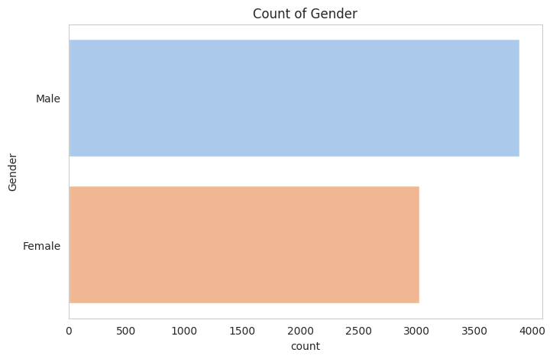

Figure 4.2.1 Customers Distribution based on Gender

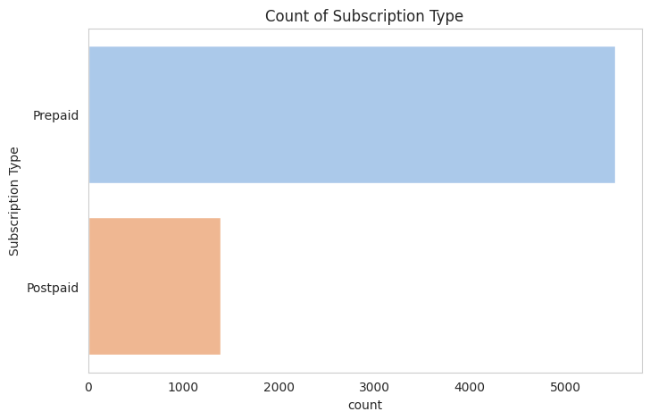

Figure 4.2.2 Customers Distribution based on Subscription Type

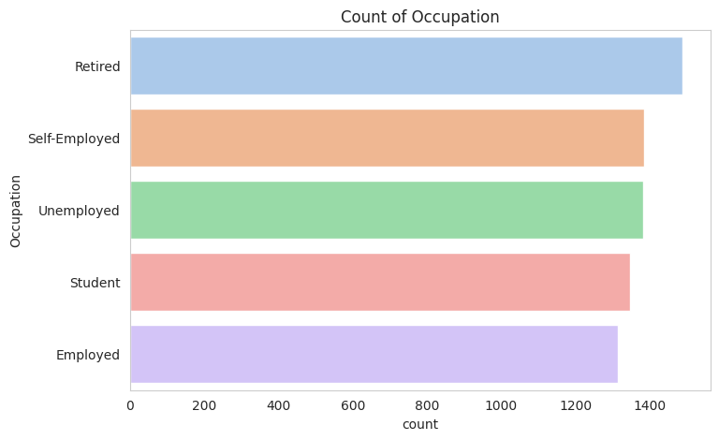

Figure 4.2.3 Customers Distribution based on Occupation

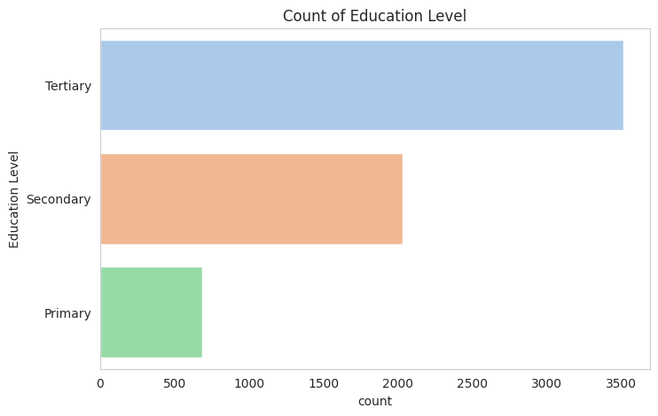

Figure 4.2.4 Customers Distribution based on Educational Level
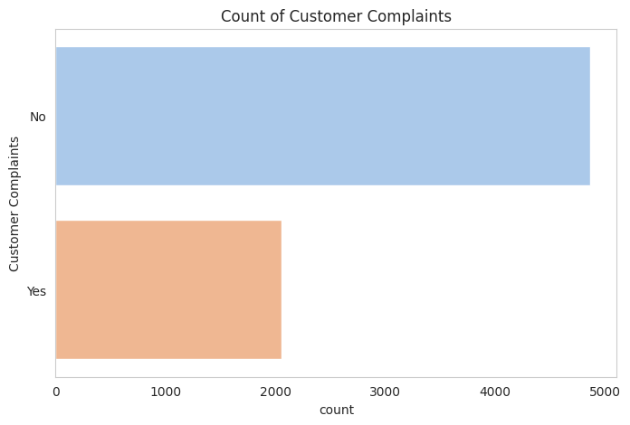

Figure 4.2.5 Customers Distribution based on Complaints

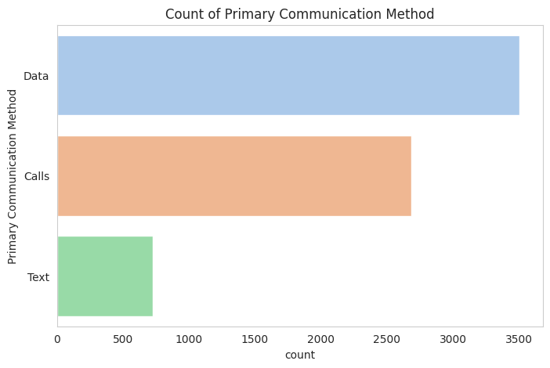

Figure 4.2.6 Customers Distribution based on Communication Method
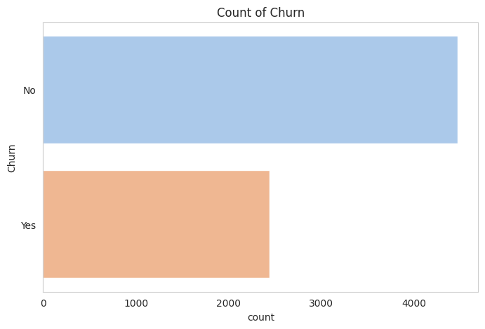

Figure 4.2.7 Customers Distribution based on Churning

The customers distribution being Age, Monthly Spending, Contract Length (Months), Monthly call Usage (Minutes), and Monthly Data Usage (GB) are presented in Figures 4.2.8 – 4.2.12.
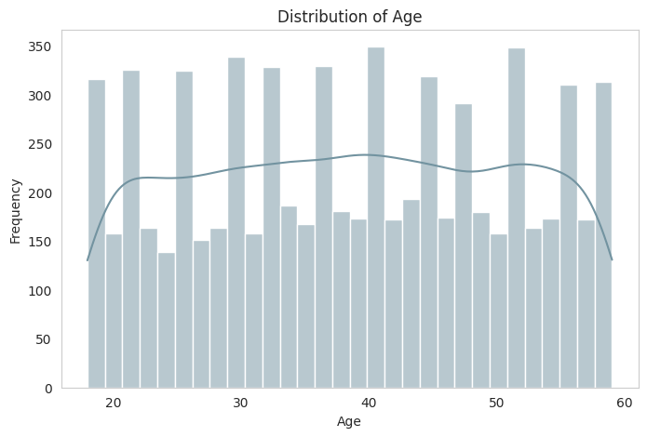

Figure 4.2.8 Customers Distribution based on Age

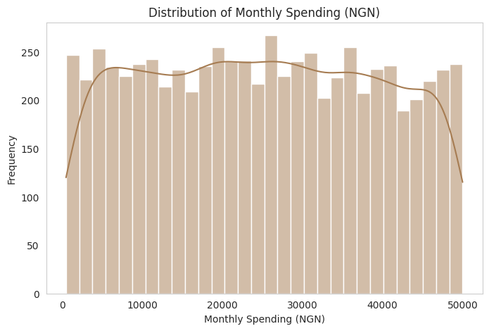

Figure 4.2.9 Customers Distribution based on Monthly Spending (NGN)

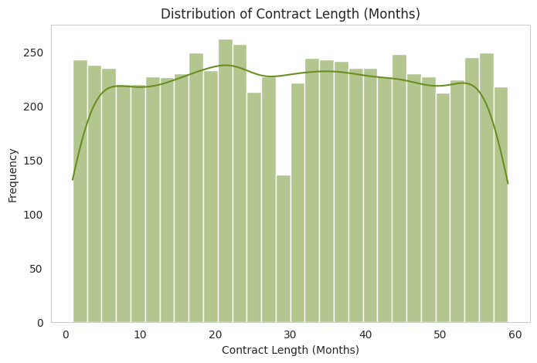

Figure 4.2.10 Customers Distribution based on Contract Length (Months)

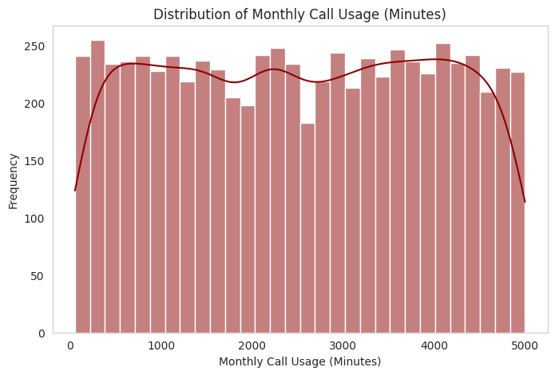

Figure 4.2.11 Customers Distribution based on Monthly Call Usage (Minutes)

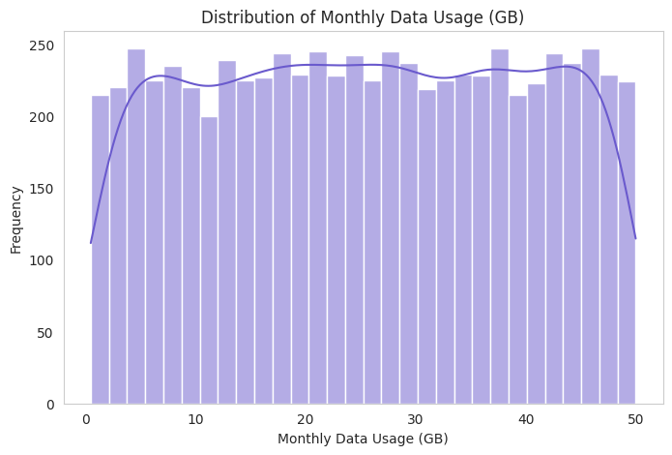

Figure 4.2.12 Customers Distribution based on Monthly Data Usage (GB)

The correlation heatmap in Figure 4.2.13 is used for feature engineering indicating important features for extraction and selection in the task of machine learning model building. Figure 4.2.13 shows the relationships between various numerical features in the telecommunications customer dataset, which can be used for churn prediction analysis. The following information can be extracted from this heatmap.

  - Age has very little correlation with any other features, indicating that it does not significantly influence monthly spending, contract length, or usage behavior.
  - Monthly Spending (NGN) is not strongly correlated with any of the other numerical features. This suggests that spending does not directly depend on contract length, call usage, or data usage, which might indicate different customer spending behaviors.
  - Contract Length (Months) has a near-zero correlation with other features, meaning that customers' contract durations do not strongly relate to their spending or usage.
  - Monthly Call Usage (Minutes) and Monthly Data Usage (GB) also show minimal correlation with other features. This means that customers' call and data usage patterns are independent of their age, contract length, and spending.

Implications for Churn Prediction
Since no strong correlations exist among these features, it suggests that churn may be influenced by other factors, such as customer service interactions, promotions, or external factors like competitor offerings.
Feature engineering was used to derive more meaningful variables that capture patterns related to churn. Result shows that non-numerical features, like contract type (prepaid vs. postpaid), customer complaints, or satisfaction scores, play a larger role in predicting churn.

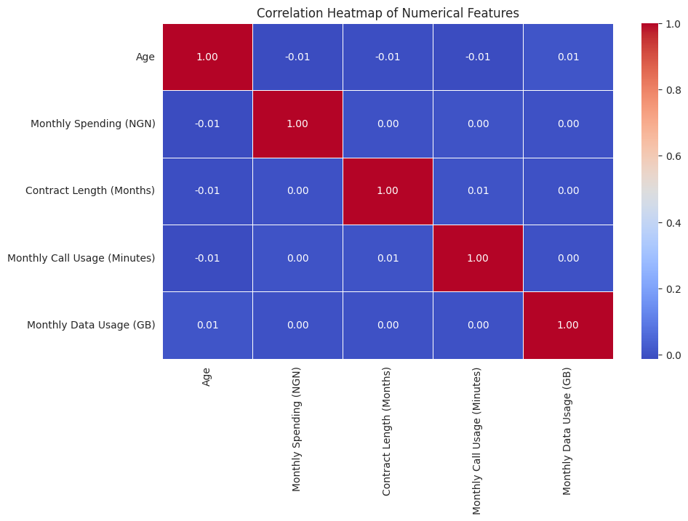

Figure 4.2.13 Correlation Heatmap

Figure 4.2.14 indicates the churn distribution of the customers while Figure 4.2.15 shows that churn rate by subscription type. Results indicate that more prepaid customers have the tendency to churn compared to postpaid customers.
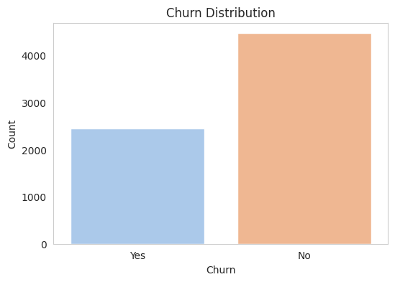

Figure 4.2.14 Churn Distribution of the Customers

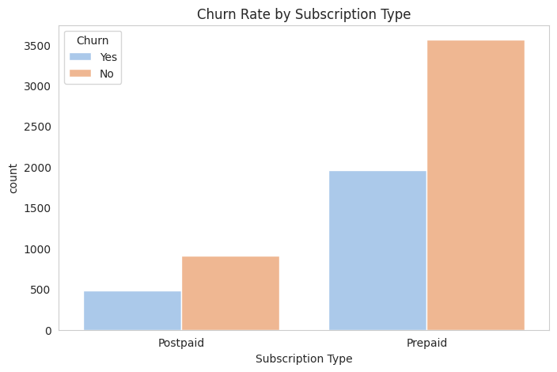

Figure 4.2.15 Churn Rate of the Customers based on Subscription Type

4.3 Machine Learning Model Performance on Churn Prediction
The Confusion matrices for each ML model is depicted in Figures 4.3.1 - 4.3.4 for the TP, TN, FP, and FN values with a total of 1,383 data points. The tabular results for diverse metrics including accuracy, recall, precision, and F1-score is presented in Tables 4.3.1 - 4.3.4
Results indicate that DT achieved the following performance in predicting customer churn: accuracy (0.54), precision (0.55), recall (0.54) and F1-score (0.55). On the other hand, RF model achieved the following performance: accuracy (0.64), precision (0.55), recall (0.64) and F1-score (0.54). Similarly, XGBoost model achieved the following performance: accuracy (0.61), precision (0.57), recall (0.61) and f1-score (0.58) while SVM achieved the following performance: accuracy (0.65), precision (0.43), recall (0.65) and F1-score (0.52).
Based on the dataset used, results indicate that SVM outperformed the ML models with highest accuracy of 65%, followed by RF (64%), XGBoost (61%) while DT had the least accuracy value of (54%). On the other hand, DT and Rf had equal precision performance (55%), XGBoost had the highest precision (57%) while SVM had the least precision (43%). In terms of recall, SVM achieved the highest performance (65%), followed by RF (64%), XGBoost (61%) while Dt had the least recall value (54%).
It can be deduced from the comparative performance plot of the ML models in Figure 4.3.5 that, based on accuracy and recall, the best model for predicting customer churn behaviour is SVM followed by RF. It therefore indicates that SVM is a powerful classification algorithm with capability to find the optimal hyperplane separating different classes in the feature space. Also, RF as an ensembled method proved its ability to combine multiple decision trees to improve predictive accuracy and reduce overfitting.

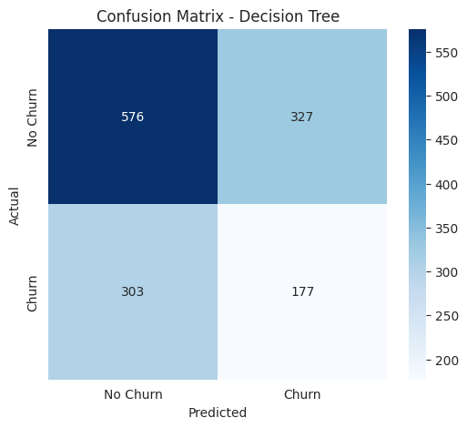

Figure 4.3.1 Confusion Matrix for DT

Table 4.3.1 Performance Evaluation Report for DT Model
precision recall f1-score support

0 0.66 0.64 0.65 903
1 0.35 0.37 0.36 480

accuracy 0.54 1383
macro avg 0.50 0.50 0.50 1383
weighted avg 0.55 0.54 0.55 1383

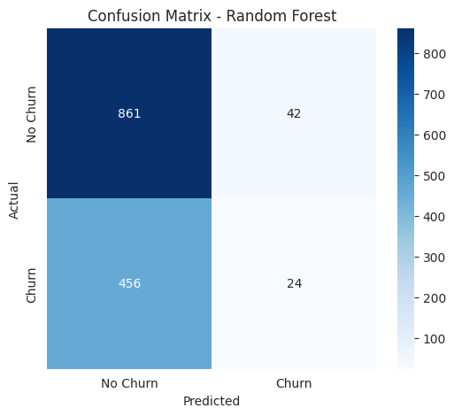

Figure 4.3.2 Confusion Matrix for RF

Table 4.3.2 Performance Evaluation Report for RF Model
precision recall f1-score support

0 0.65 0.95 0.78 903
1 0.36 0.05 0.09 480

accuracy 0.64 1383
macro avg 0.51 0.50 0.43 1383
weighted avg 0.55 0.64 0.54 1383

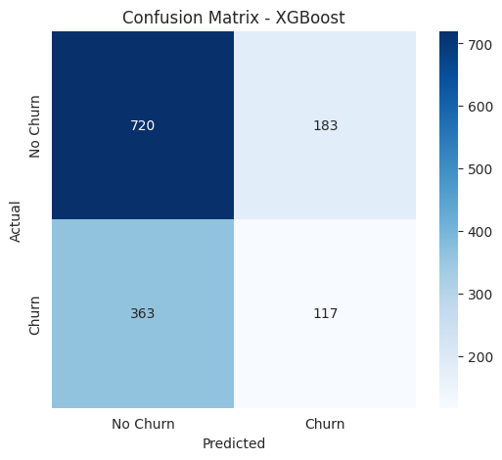

Figure 4.3.3 Confusion Matrix for XGBoost

Table 4.3.3 Performance Evaluation Report for XGBoost Model
precision recall f1-score support

0 0.66 0.80 0.73 903
1 0.39 0.24 0.30 480

accuracy 0.61 1383
macro avg 0.53 0.52 0.51 1383
weighted avg 0.57 0.61 0.58 1383

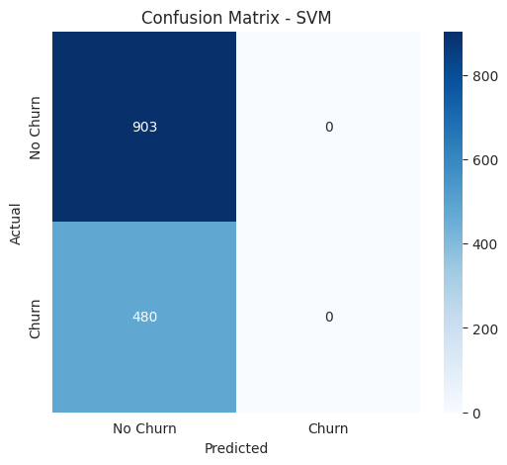

Figure 4.3.4 Confusion Matrix for SVM

Table 4.3.4 Performance Evaluation Report for SVM Model
precision recall f1-score support

0 0.65 1.00 0.79 903
1 0.00 0.00 0.00 480

accuracy 0.65 1383
macro avg 0.33 0.50 0.40 1383
weighted avg 0.43 0.65 0.52 1383

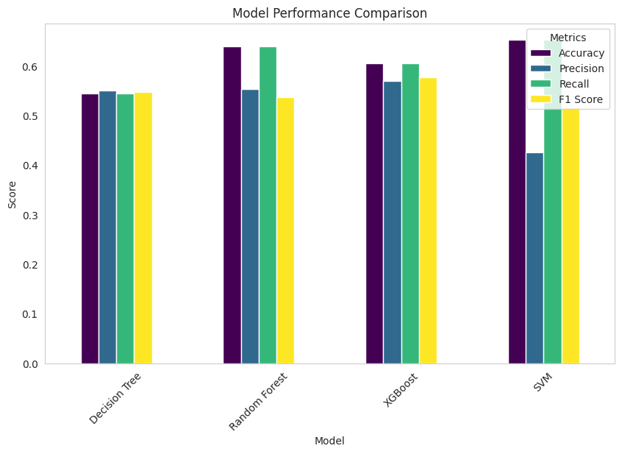

Figure 4.3.5 Comparative Performance of the ML Models

CHAPTER FIVE

SUMMARY, RECOMMENDATIONS AND CONCLUSION

5.1 Summary
This chapter provides a summary of the key findings, conclusions, and recommendations drawn from the study on customer churn in the Nigerian telecommunications sector, with a particular focus on MTN and Airtel. The aim was to identify the primary factors contributing to customer churn, evaluate the performance of various machine learning models for churn prediction, and compare the effectiveness of these models. The findings and conclusions presented in this chapter will provide a foundation for developing strategies to reduce churn and enhance customer retention in the telecommunications industry.

The analysis carried out in Chapter Four highlighted several important factors and insights:
- Key Factors Influencing Customer Churn:
The study identified several factors that significantly influence customer churn, including service quality, network coverage, customer service, billing issues, and offers and promotions. Among these, poor service quality and network coverage issues were the most frequently cited reasons for customers switching providers.
- Evaluation of Machine Learning Models:
The study evaluated multiple machine learning models—Decision Tree, Random Forest, Support Vector Machine (SVM), and Extreme Gradient Boosting (XGBoost)—to predict customer churn in telecommunications industry. The SVM model outperformed all others in terms of accuracy (0.65) and recall(0.65), making it the most effective tool for predicting churn.

- Model Comparison:
A detailed comparison of the models showed that Random Forest also performed well, closely following SVm with accuracy and recall of 64% respectively. XGBoost exhibited moderate performance while DT had the least accuracy and prediction reliability.

5.2 Recommendations
The following recommendations are made based on the study findings:
- Service Improvement Initiatives: Telecommunication companies, particularly MTN and Airtel, should invest in infrastructure upgrades to improve network coverage and service quality, which were the primary reasons for customer dissatisfaction.
- Utilizing Predictive Models: Companies should integrate the SVM model into their customer management systems to accurately predict churn and intervene early by offering targeted retention strategies such as loyalty programs, personalized offers, or addressing specific grievances.
- Customer Feedback Mechanisms: Establishing more effective customer feedback loops can help identify service deficiencies before they escalate to churn. Implementing regular surveys, quick issue-resolution platforms, and more responsive customer service can significantly enhance customer satisfaction.
- Customized Offers: Companies should consider developing more personalized promotions and incentives based on customer spending patterns and preferences. These could include data and voice bundles, price discounts, and special offers for long-term customers.

5.3 Conclusion
Based on the findings from the data analysis and model evaluation, several conclusions can be drawn:
- Service Quality and Customer Satisfaction: The study confirms that service quality remains the most critical determinant of customer loyalty in the Nigerian telecommunications industry. Customers are highly likely to switch providers due to poor service experiences, particularly concerning network coverage and billing issues.
- Churn Prediction: The use of machine learning models for churn prediction has proven to be effective. The SVM emerged as the most accurate model for predicting customer churn, making it a valuable tool for telecom operators seeking to identify at-risk customers before they leave.
- Improving Customer Retention: To minimize churn, telecommunications companies need to prioritize improving network reliability, billing transparency, and customer service. Additionally, offering competitive promotions and packages tailored to customer needs could help retain existing customers and attract new ones.

5.5 Future Enhancement
Future research could expand the scope of the study to include a broader range of telecom operators and a larger dataset to validate the findings. Additionally, exploring the integration of machine learning with real-time customer analytics may provide even deeper insights into churn behavior and help telecom companies react proactively to customer needs.

5.6 Research Contribution
- Churn Factors: The research identifies critical drivers of customer churn in Nigeria's telecom industry, particularly service quality and network coverage.
- Machine Learning Application: This study demonstrates the effective use of machine learning models for churn prediction, with SVM outperforming others.
- Nigerian Context: It provides insights specific to the Nigerian telecom sector, addressing the gap in local churn prediction studies.

REFERENCES
Abdulkareem, R. A., Oladokun, V. O., & Adeniyi, F. A. (2019). Customer churn analysis for telecom firms in developing countries. International Journal of Data Science, 10(3), 212-227.
Abreu, J., Nogueira, J., Becker, V., and Cardoso, B. (2016). Survey of Catch-up TV and other time-shift services: a comprehensive analysis and taxonomy of linear and nonlinear television. Telecommunication Systems, 64(1), 57–74. https://doi.org/10.1007/s11235-016-0157-3
Aggarwal, C. C. (2015). Data Mining: The Textbook. Springer.
Ahn, J. H., Han, S. P., and Lee, Y. S. (2016). Customer churn analysis: Churn determinants and mediation effects of partial defection in the Korean mobile telecommunications service industry. Telecommunications Policy, 30(10-11), 552-568.
Ajzen, I. (1991). The theory of planned behavior. Organizational Behavior and Human Decision Processes, 50(2), 179-211.
Allison, P. D. (2012). Logistic Regression Using SAS: Theory and Application. SAS Institute.
Amin, A., Al-Obeidat, F., Shah, B., Adnan, A., Loo, J., & Anwar, S. (2018). Customer churn prediction in telecommunication industry using data certainty. Journal of Business Research, 94, 290–301. https://doi.org/10.1016/j.jbusres.2018.03.003
Amin, A., Anwar, S., Adnan, A., Nawaz, M., Howard, N., Qadir, J., ... and Hussain, A. (2019). Customer churn prediction in the telecommunication sector using a rough set approach. Neurocomputing, 237, 242-254.
Anderson, R. E. (2018). Customer satisfaction and word of mouth. Journal of Service Research, 1(1), 5-17.
Anderson, R. E., and Srinivasan, S. S. (2003). E‐satisfaction and e‐loyalty: A contingency framework. Psychology and Marketing, 20(2), 123-138.
Bandyopadhyay, S., and Martell, M. (2017). Does attitudinal loyalty influence behavioral loyalty? A theoretical and empirical study. Journal of Retailing and Consumer Services, 14(1), 35-44.
Bishop, C. M. (2006). Pattern Recognition and Machine Learning. Springer.
Blattberg, R. C., Malthouse, E. C., and Neslin, S. A. (2019). Customer lifetime value: Empirical generalizations and some conceptual questions. Journal of Interactive Marketing, 23(2), 157-168.
Bolton, R. N., Lemon, K. N., and Verhoef, P. C. (2020). The theoretical underpinnings of customer asset management: A framework and propositions for future research. Journal of the Academy of Marketing Science, 32(3), 271-292.
Breiman, L. (2001). Random forests. Machine Learning, 45(1), 5-32.
Bryman, A., and Bell, E. (2015). Business Research Methods (4th ed.). Oxford University Press.
Burnham, T. A., Frels, J. K., and Mahajan, V. (2003). Consumer switching costs: A typology, antecedents, and consequences. Journal of the Academy of Marketing Science, 31(2), 109-126.
Chang, V., Hall, K., Xu, Q., Amao, F., Ganatra, M., & Benson, V. (2024). Prediction of customer churn behavior in the telecommunication industry using machine learning models. Algorithms, 17(6), 231. https://doi.org/10.3390/a17060231
Chen, T., and Guestrin, C. (2016). XGBoost: A scalable tree boosting system. In Proceedings of the 22nd ACM SIGKDD International Conference on Knowledge Discovery and Data Mining (pp. 785-794).
Chen, Z., Lee, Y., & Park, J. (2020). Application of ensemble models for customer churn prediction: A case study in the telecom sector. Computers in Human Behavior, 107, 105752.
Cortes, C., and Vapnik, V. (1995). Support-vector networks. Machine Learning, 20(3), 273-297.
Cox, D. R. (1972). Regression Models and Life-Tables (with Discussion). Journal of the Royal Statistical Society: Series B (Methodological), 34(2), 187-220.
Davis, F. D. (1989). Perceived usefulness, perceived ease of use, and user acceptance of information technology. MIS Quarterly, 13(3), 319-340.
De Bruyn, A., and Lilien, G. L. (2018). A multi-stage model of word-of-mouth influence through viral marketing. International Journal of Research in Marketing, 25(3), 151-163.
Deloitte. (2020). The Future of the Telecommunications Industry: A Dual Transformation. Retrieved from Deloitte
Dick, A. S., and Basu, K. (1994). Customer loyalty: Toward an integrated conceptual framework. Journal of the Academy of Marketing Science, 22(2), 99-113.
Domingos, P. (2012). A few useful things to know about machine learning. Communications of the ACM, 55(10), 78-87.
Ernst and Young. (2019). Digital Disruption in India: Transforming Consumer Services. Retrieved from EY India
Field, A. (2013). Discovering Statistics Using IBM SPSS Statistics (4th ed.). SAGE Publications.
Gartner. (2021). Market Insights: US Telecommunications Industry. Retrieved from Gartner
Gerpott, T. J., Rams, W., and Schindler, A. (2021). Customer retention, loyalty, and satisfaction in the German mobile cellular telecommunications market. Telecommunications Policy, 25(4), 249-269.
Gupta, S., Lehmann, D. R., and Stuart, J. A. (2016). Valuing customers. Journal of Marketing Research, 41(1), 7-18.
Guyon, I., and Elisseeff, A. (2003). An introduction to variable and feature selection. Journal of Machine Learning Research, 3, 1157-1182.
Hastie, T., Tibshirani, R., and Friedman, J. (2009). The Elements of Statistical Learning: Data Mining, Inference, and Prediction. Springer.
He, H., and Garcia, E. A. (2019). Learning from imbalanced data. IEEE Transactions on Knowledge and Data Engineering, 21(9), 1263-1284.
Homburg, C., and Giering, A. (2021). Personal characteristics as moderators of the relationship between customer satisfaction and loyalty—An empirical analysis. Psychology and Marketing, 18(1), 43-66.
Hosmer, D. W., Lemeshow, S., and Sturdivant, R. X. (2013). Applied Logistic Regression (3rd ed.). Wiley.
Huang, T., and Wang, M. (2018). Customer Churn Analysis in Telecommunications. Journal of Business Research, 85, 23-34.
Huang, T., and Wang, X. (2018). Network performance and customer loyalty in the telecommunications industry. Journal of Business Research, 85, 1-11.
James, G., Witten, D., Hastie, T., and Tibshirani, R. (2013). An Introduction to Statistical Learning: With Applications in R. Springer.
Jiang, Z., and Klein, G. (2009). A discrepancy model of information system personnel turnover. Journal of Management Information Systems, 25(3), 259-284.
Kantarcioglu, M., Jiang, W., Liu, Y., and Malin, B. (2020). A brief overview of data privacy laws and their impact on AI. IEEE Security and Privacy, 18(6), 20-28.
Kim, S., Lee, Y., and Ahn, J. H. (2021). Managing customer churn in the telecommunications industry: A customer retention strategy using machine learning models. Telecommunications Policy, 45(7), 102101.
Kleinbaum, D. G., & Klein, M. (2012). Survival Analysis: A Self-Learning Text (3rd ed.). New York: Springer.
Kotler, P., and Keller, K. L. (2016). Marketing Management (15th ed.). Pearson.
Krawczyk, B. (2016). Learning from imbalanced data: Open challenges and future directions. Progress in Artificial Intelligence, 5(4), 221-232.
Kshetri, N. (2017). 1 Big Data's Impact on Privacy, Security and Consumer Welfare. In Big Data for Development (pp. 37-53). Springer.
LeCun, Y., Bengio, Y., and Hinton, G. (2015). Deep learning. Nature, 521(7553), 436-444.
Lee, H. S. (2020). Understanding customer churn in the telecommunications industry: Using sentiment analysis on customer reviews. Service Business, 14(3), 363-376.
Lemmens, A., and Croux, C. (2016). Bagging and boosting classification trees to predict churn. Journal of Marketing Research, 43(2), 276-286.
Li, X., and Liu, Y. (2018). A survey of churn prediction using machine learning techniques. Journal of Computer Science and Technology, 33(1), 95-105.
Lipton, Z. C. (2018). The mythos of model interpretability. Communications of the ACM, 61(10), 36-43.
Liu, D. R., and Shih, Y. Y. (2015). Integrating AHP and data mining for product recommendation based on customer lifetime value. Information and Management, 42(3), 387-400.
Lundberg, S. M., and Lee, S.-I. (2017). A unified approach to interpreting model predictions. In Advances in Neural Information Processing Systems (pp. 4765-4774).
McKinsey and Company. (2021). The State of the French Telecommunications Market. Retrieved from McKinsey
Menard, S. (2002). Applied Logistic Regression Analysis (2nd ed.). SAGE Publications.
Molnar, C. (2020). Interpretable Machine Learning: A Guide for Making Black Box Models Explainable. Independently published.
Moro, S., Cortez, P., and Rita, P. (2019). A data-driven approach to predict the success of bank telemarketing. Decision Support Systems, 62, 22-31.
Newman, N., Levy, D., & Nielsen, R. K. (2015). Reuters Institute Digital News Report 2015. SSRN Electronic Journal. https://doi.org/10.2139/ssrn.2619576
Nguyen, B., and Simkin, L. (2017). The dark side of digital personalization: The paradox of customer loyalty and disloyalty. Journal of Business Research, 80, 86-97.
Nguyen, T. H., & Zhou, X. (2020). Customer churn prediction in the telecommunications industry: An evaluation of machine learning techniques. Journal of Big Data, 7(1), 15-29.
Nigerian Communications Commission. (2023). Industry Statistics. Retrieved from NCC
Oladipo, S. A., Yusuf, M. O., & Adeyemi, A. I. (2021). Challenges in customer churn prediction for emerging markets: The Nigerian telecom sector. African Journal of Data Analytics, 12(1), 45-58.
Oliver, R. L. (2019). A cognitive model of the antecedents and consequences of satisfaction decisions. Journal of Marketing Research, 17(4), 460-469.
Provost, F., and Fawcett, T. (2013). Data Science for Business: What You Need to Know About Data Mining and Data-Analytic Thinking. O'Reilly Media.
PwC. (2021). Africa Gearing Up: Future Prospects in Africa for the Transportation and Logistics Industry. Retrieved from PwC
Reichheld, F. F., and Sasser, W. E. (1990). Zero defections: Quality comes to services. Harvard Business Review, 68(5), 105-111.
Rudin, C. (2019). Stop explaining black box machine learning models for high stakes decisions and use interpretable models instead. Nature Machine Intelligence, 1(5), 206-215.
Sharma, P., & Gupta, S. (2018). A comprehensive study on customer churn prediction using machine learning techniques. IEEE Transactions on Computational Social Systems, 5(2), 348-359.
Smith, A. D. (2019). Billing transparency and customer retention in the telecommunications industry. Journal of Financial Services Marketing, 24(1-2), 38-53.
Sprague, R. H., and Carlson, E. D. (1982). Building Effective Decision Support Systems. Prentice Hall.
Sutton, R. S., and Barto, A. G. (2018). Reinforcement Learning: An Introduction. MIT Press.
Systematic Country Diagnostic. (2020). In World Bank, Washington, DC eBooks. https://doi.org/10.1596/34777
Ullah, I., Raza, B., Malik, A. K., Imran, M., Islam, S. U., & Kim, S. W. (2019). A Churn Prediction Model using Random Forest: Analysis of machine learning techniques for churn prediction and factor identification in telecom sector. IEEE Access, 7, 60134–60149. https://doi.org/10.1109/access.2019.2914999
Verhoef, P. C. (2013). Understanding the effect of customer relationship management efforts on customer retention and customer share development. Journal of Marketing, 67(4), 30-45.
Verhoef, P. C., and Lemon, K. N. (2010). Successful customer value management: Key lessons and emerging trends. European Management Journal, 28(1), 49-61.
Verhoef, P. C., Lemon, K. N., Parasuraman, A., Roggeveen, A. L., Tsiros, M., and Schlesinger, L. A. (2016). Customer experience creation: Determinants, dynamics and management strategies. Journal of Retailing, 92(2), 127-144.
Vlachos, I. (2018). Corporate governance practices and firm performance: Evidence from the telecommunications industry. Journal of Corporate Governance, 16(4), 620-632.
Wang, R. Y., and Strong, D. M. (1996). Beyond accuracy: What data quality means to data consumers. Journal of Management Information Systems, 12(4), 5-33.
Wei, C. P., and Chiu, I. T. (2022). Turning telecommunications call details to churn prediction: A data mining approach. Expert Systems with Applications, 23(2), 103-112.
Wirtz, J., and Lihotzky, N. (2023). Customer churn in the mobile telecommunications industry: Predicting a successful strategy. Journal of Service Research, 5(4), 363-377.
Xu, Y., Goodacre, R., and He, F. (2020). The use of artificial intelligence to predict customer churn in telecommunications industry. International Journal of Automation and Computing, 17(4), 477-491.
Yang, Z., and Peterson, R. T. (2014). Customer perceived value, satisfaction, and loyalty: The role of switching costs. Psychology and Marketing, 21(10), 799-822.

